Inheritance :

class A:  
 def feature1(self):  
 print("feature 1 is working")  
  
 def fetaure2(self):  
 print("feature2 working")  
class B():  
 def feature3(self):  
 print("feature 3 is working")  
  
 def fetaure4(self):  
 print("feature 4 working")  
class C(B,A):  
 def feature5(self):  
 print("feature 5 is working")  
  
  
a1=A()  
a1.feature1()  
a1.fetaure2()  
b1=B()  
b1.fetaure4()  
b1.feature3()  
c1=C()  
c1.feature5()

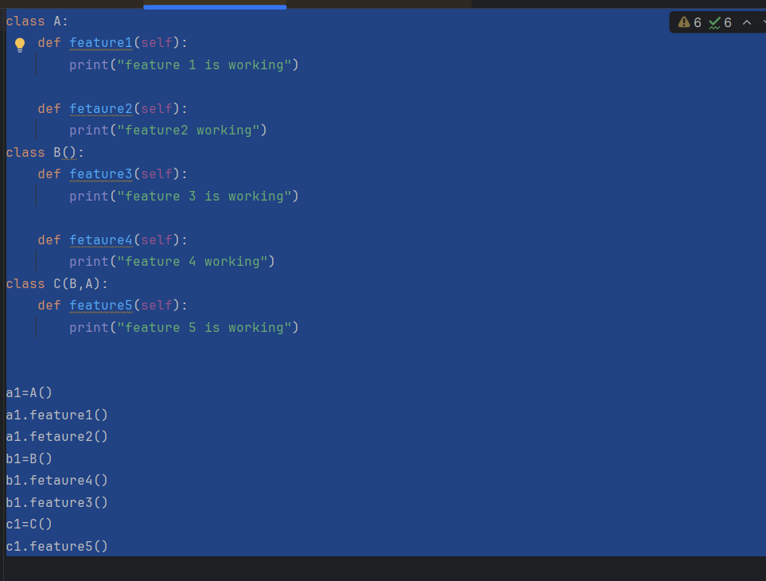

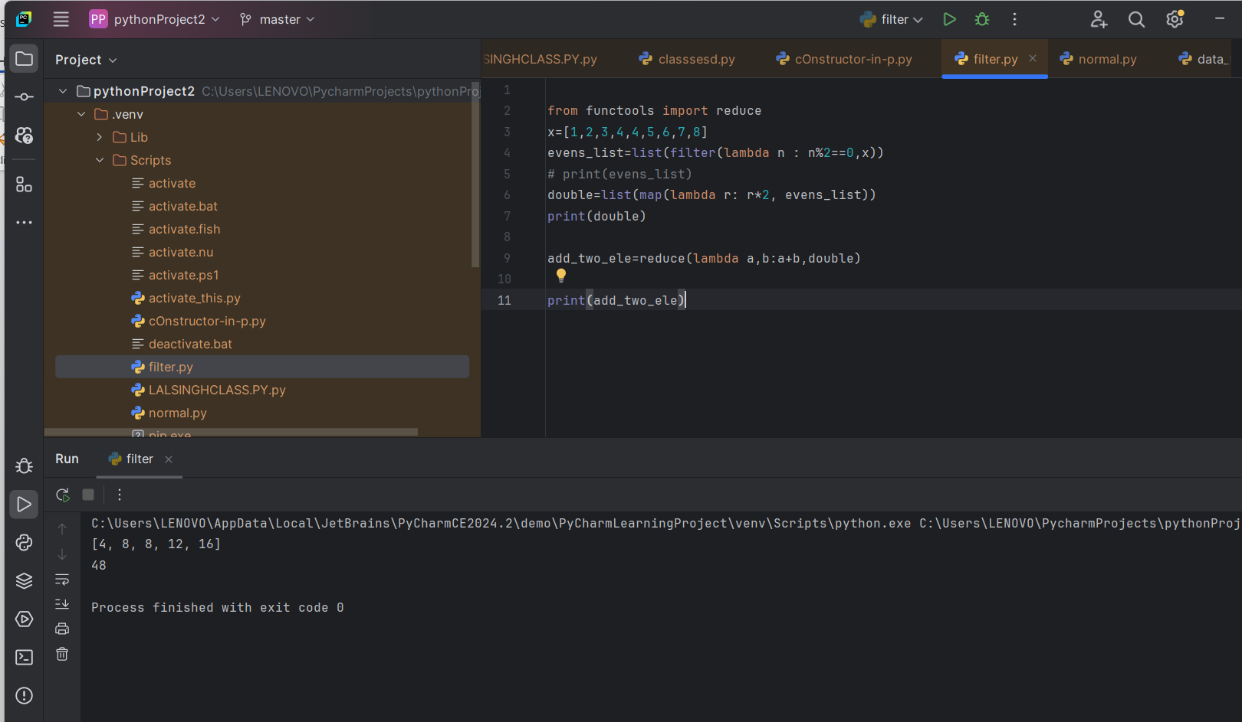

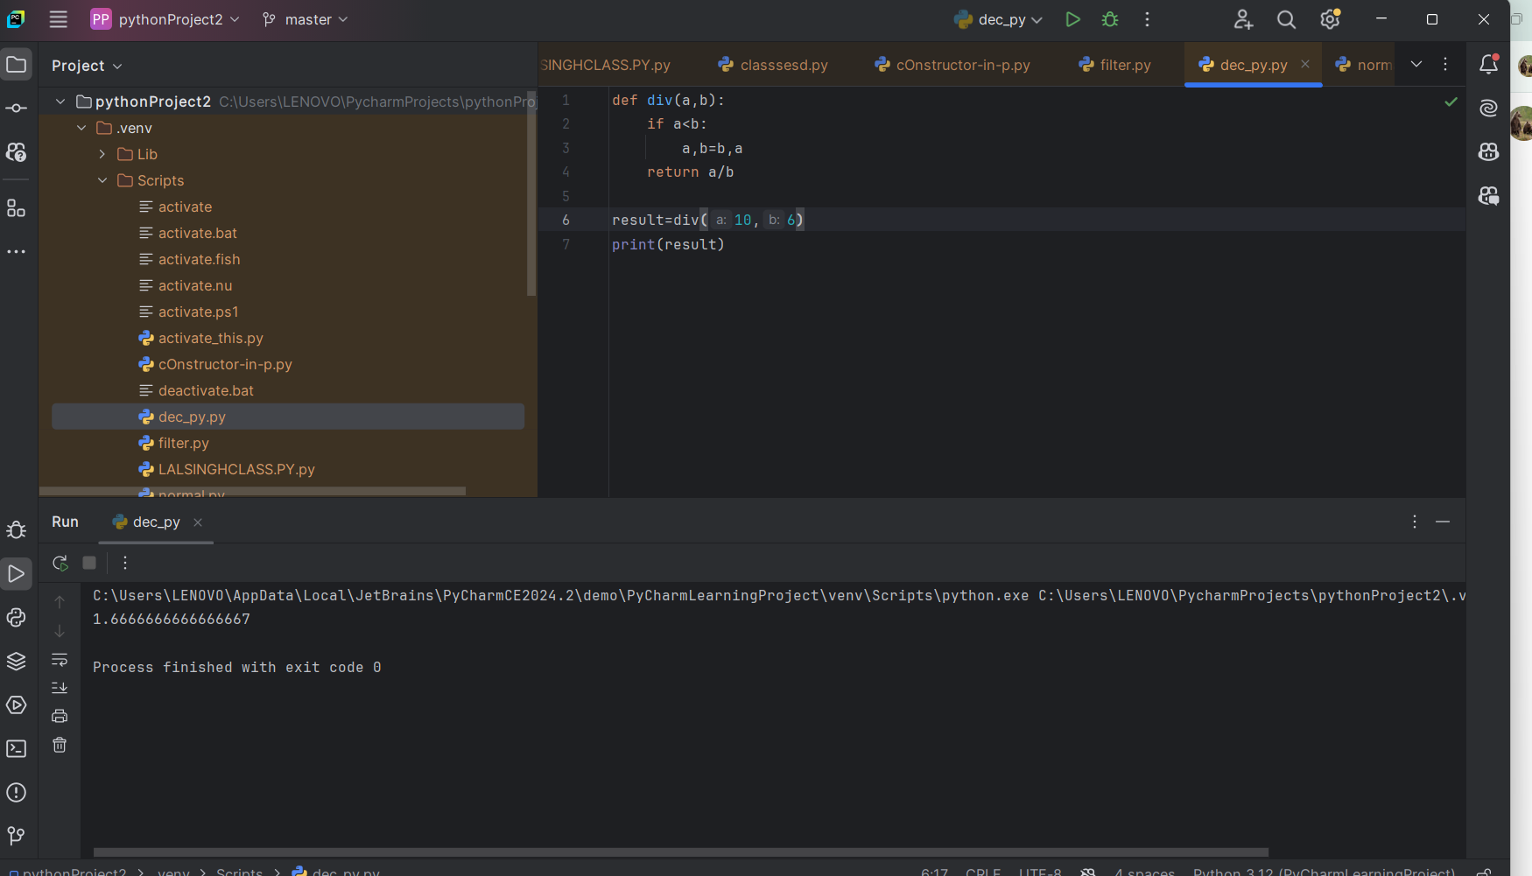

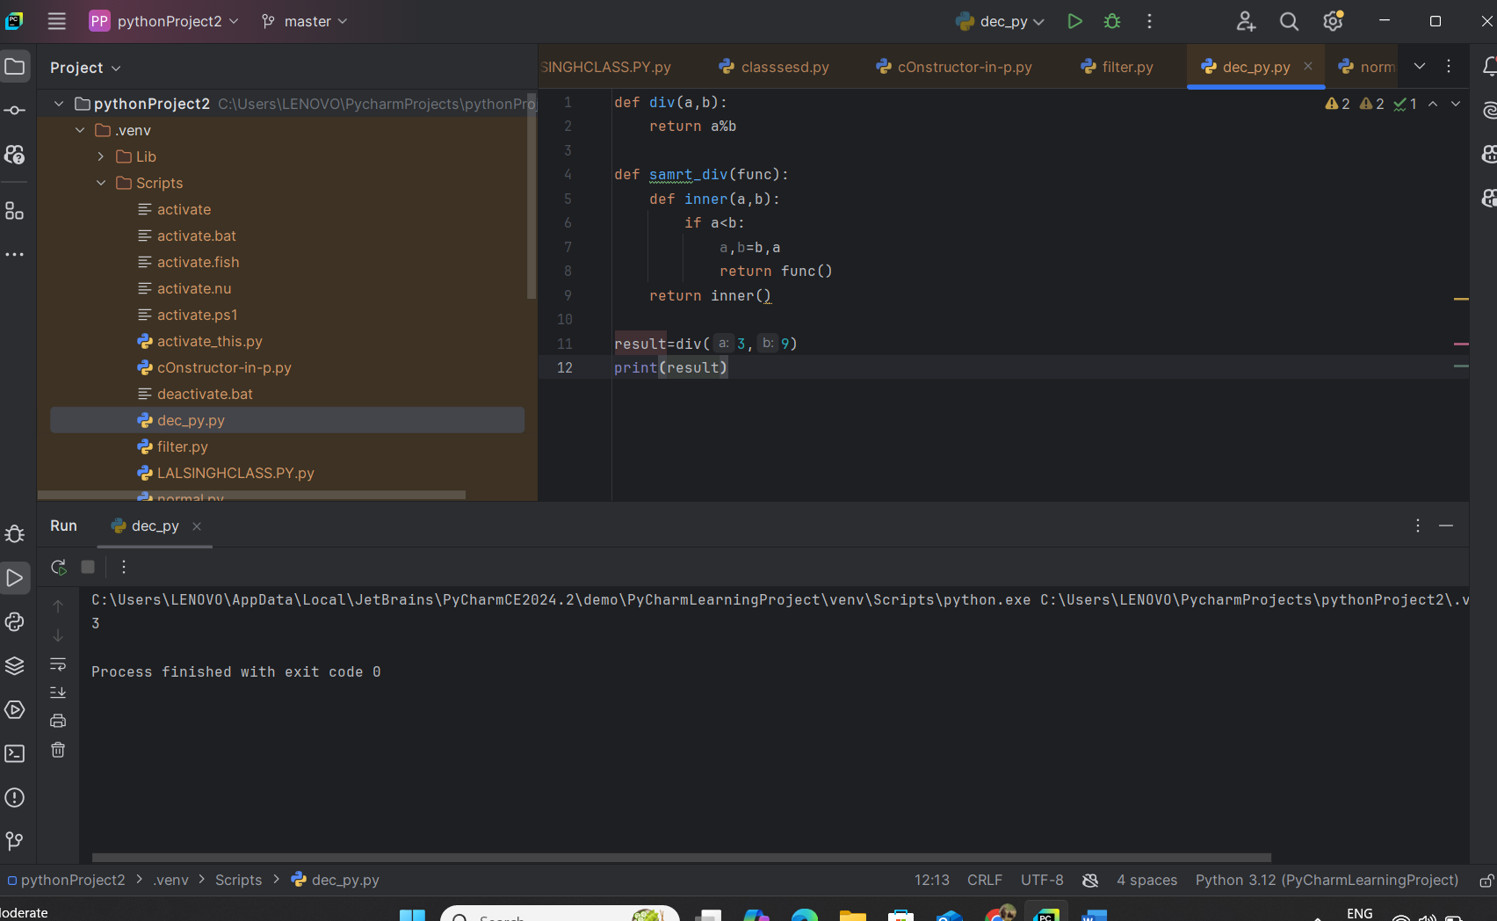

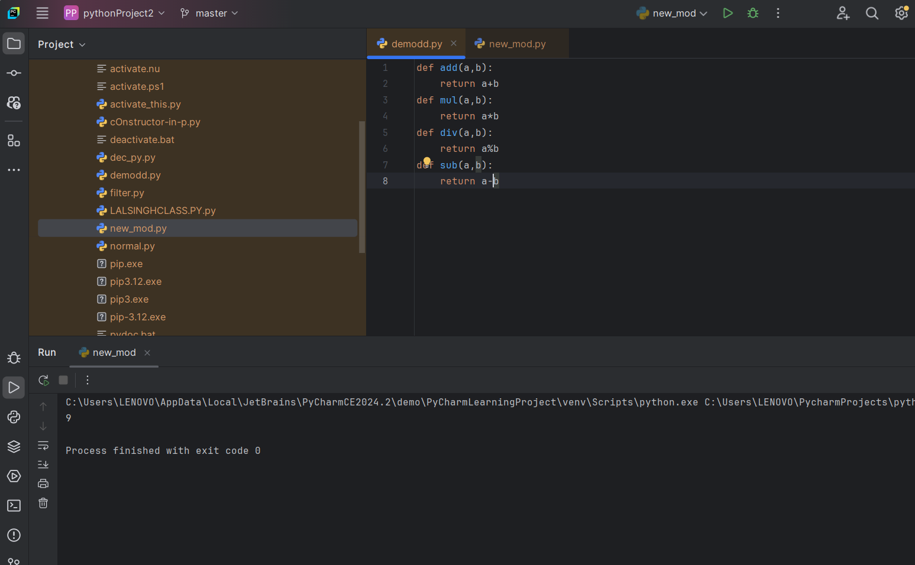

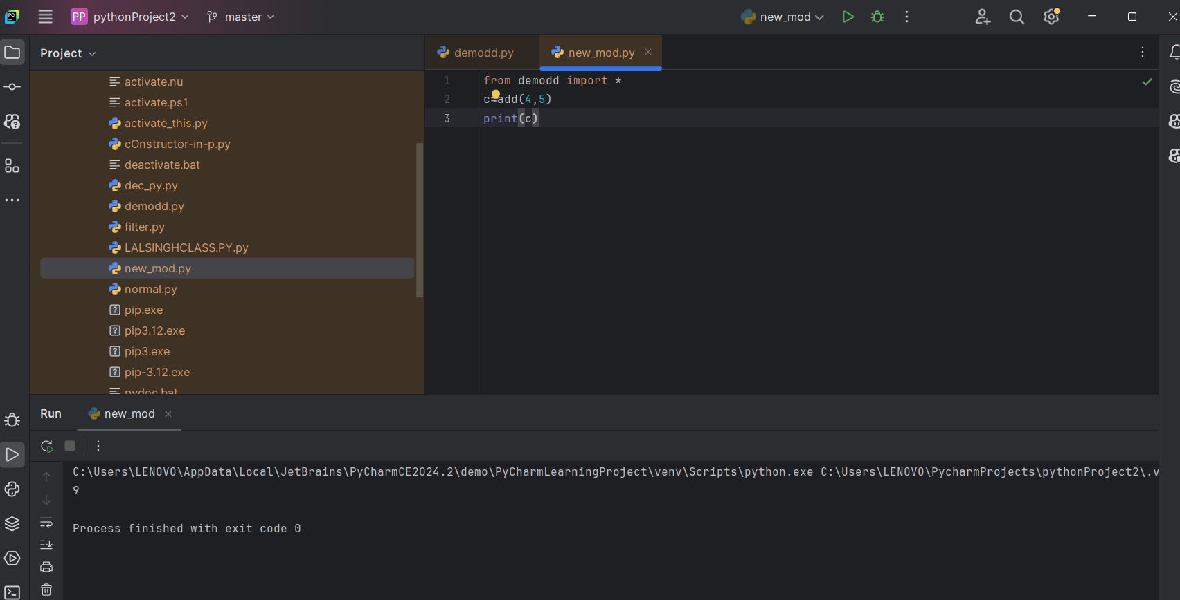

25-11-2024 – 11:00am

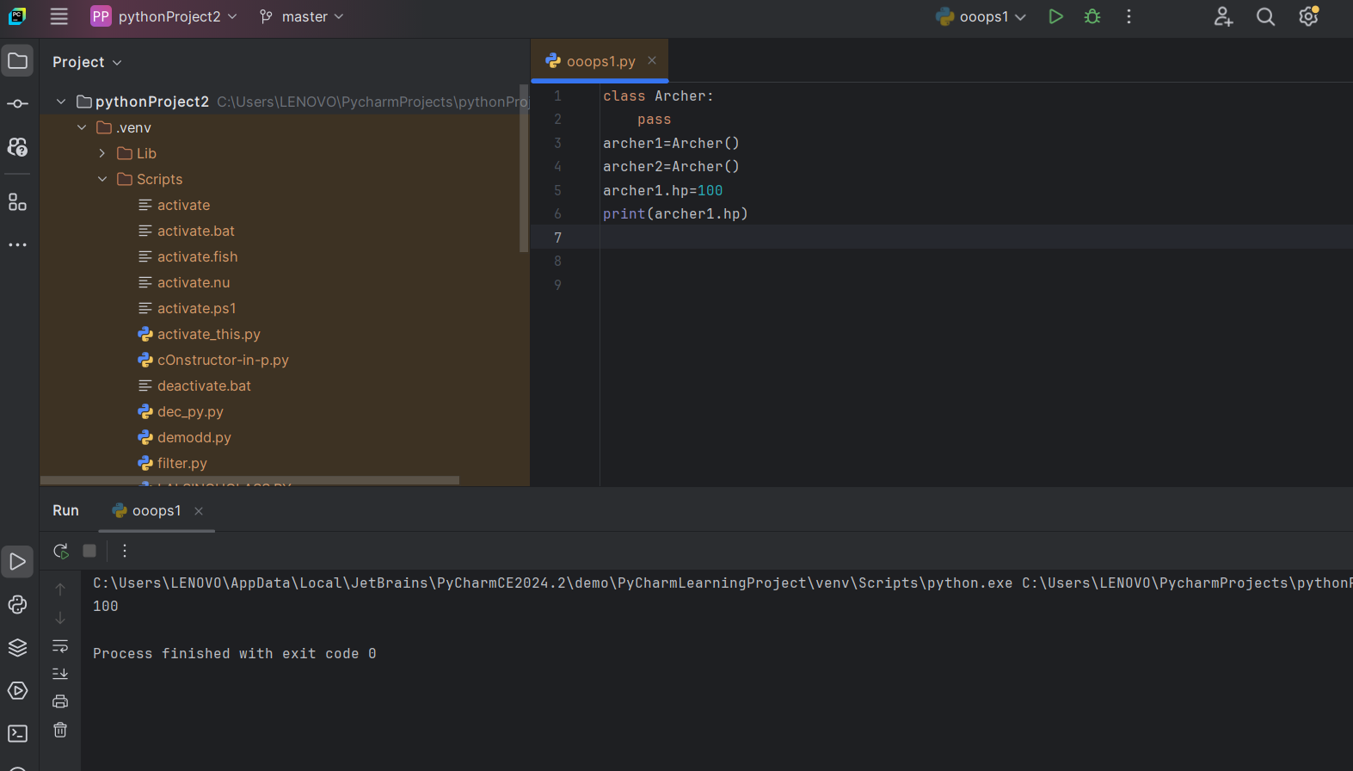

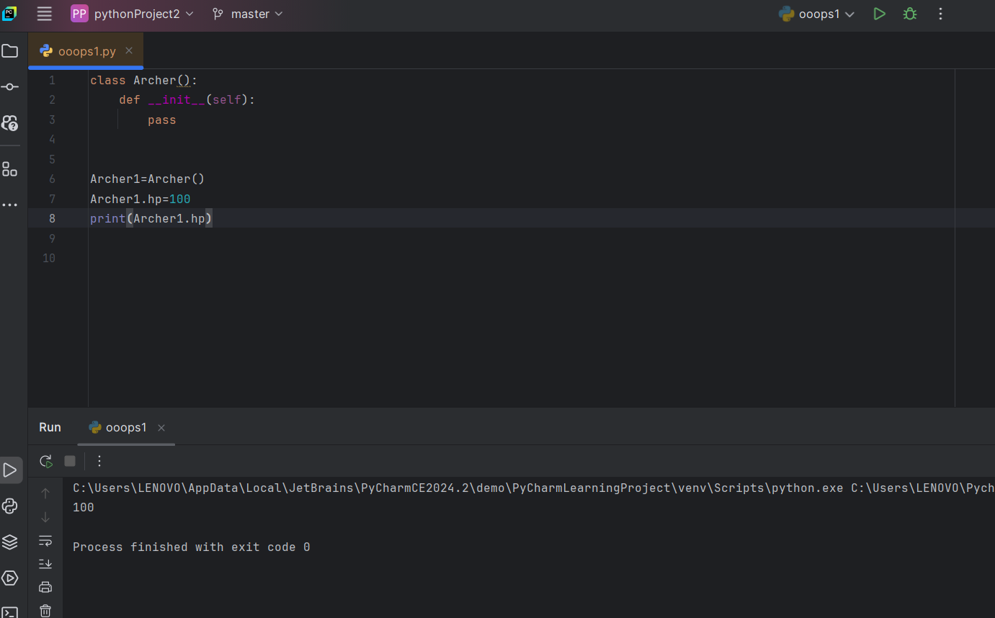

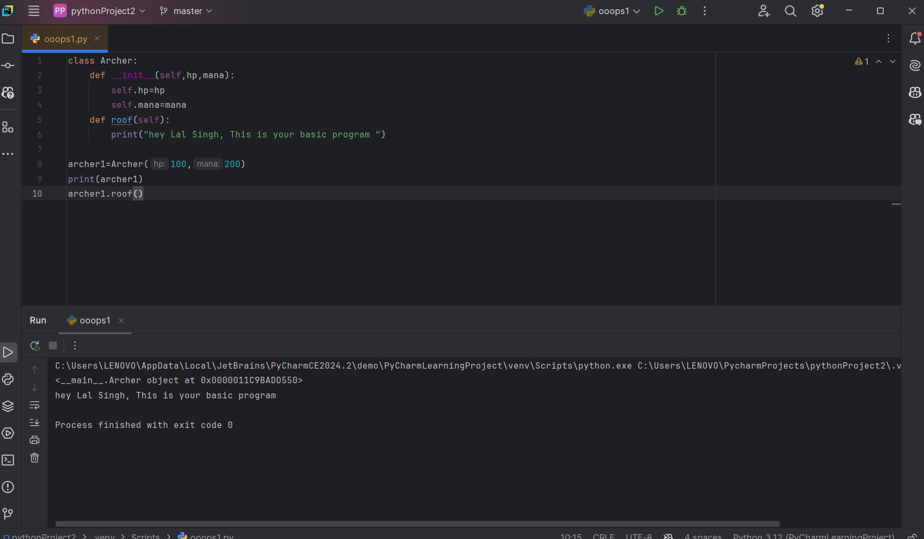

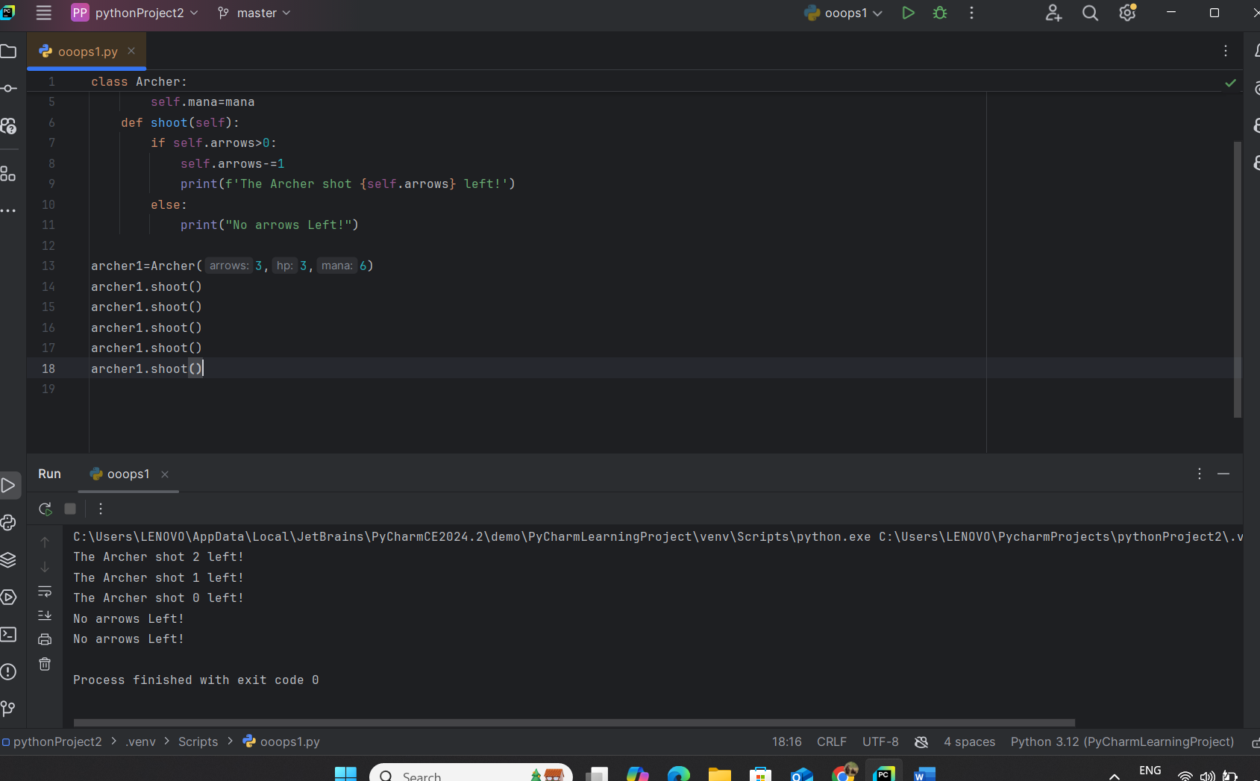

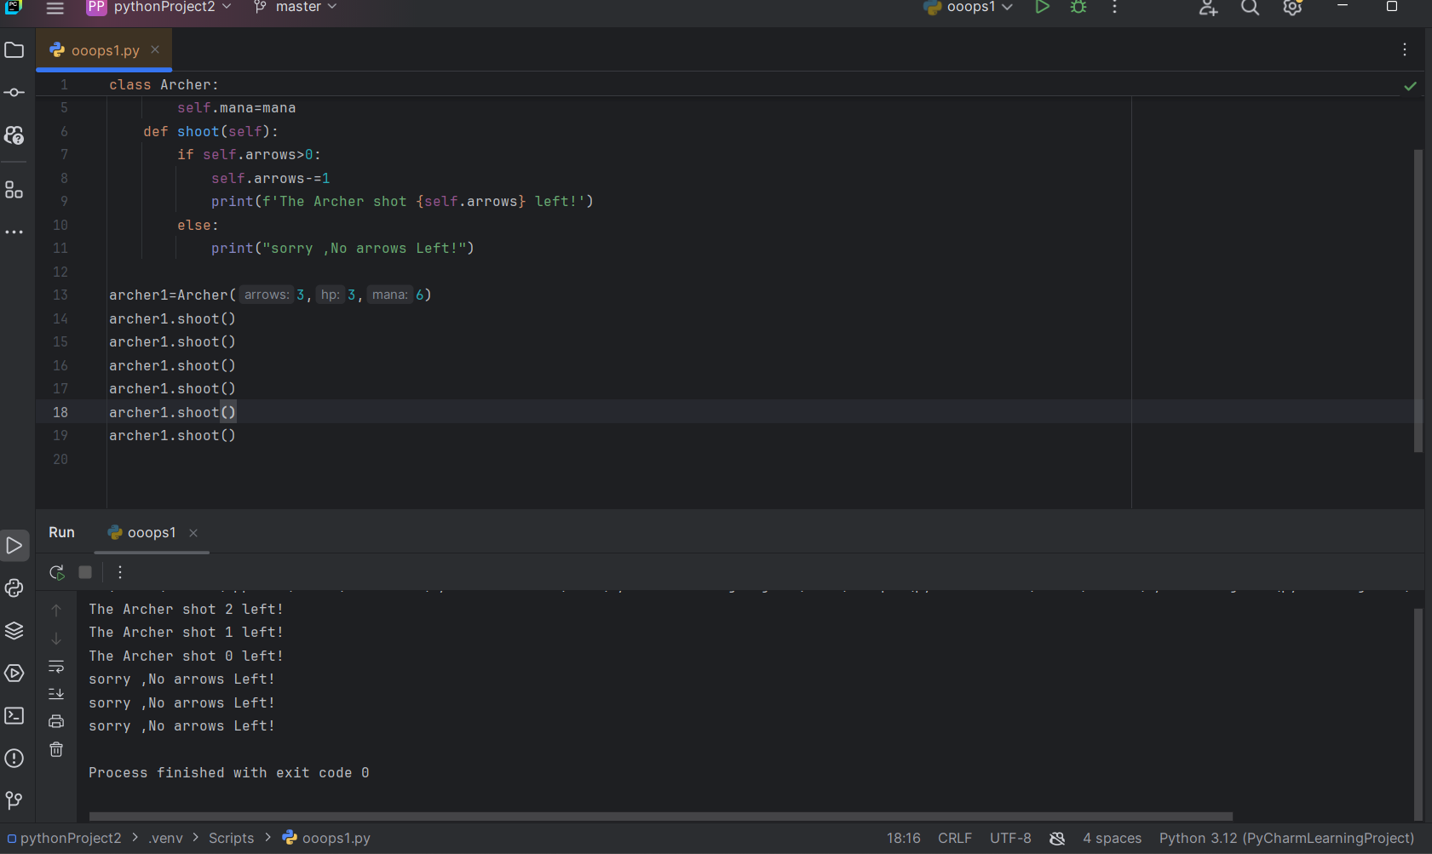

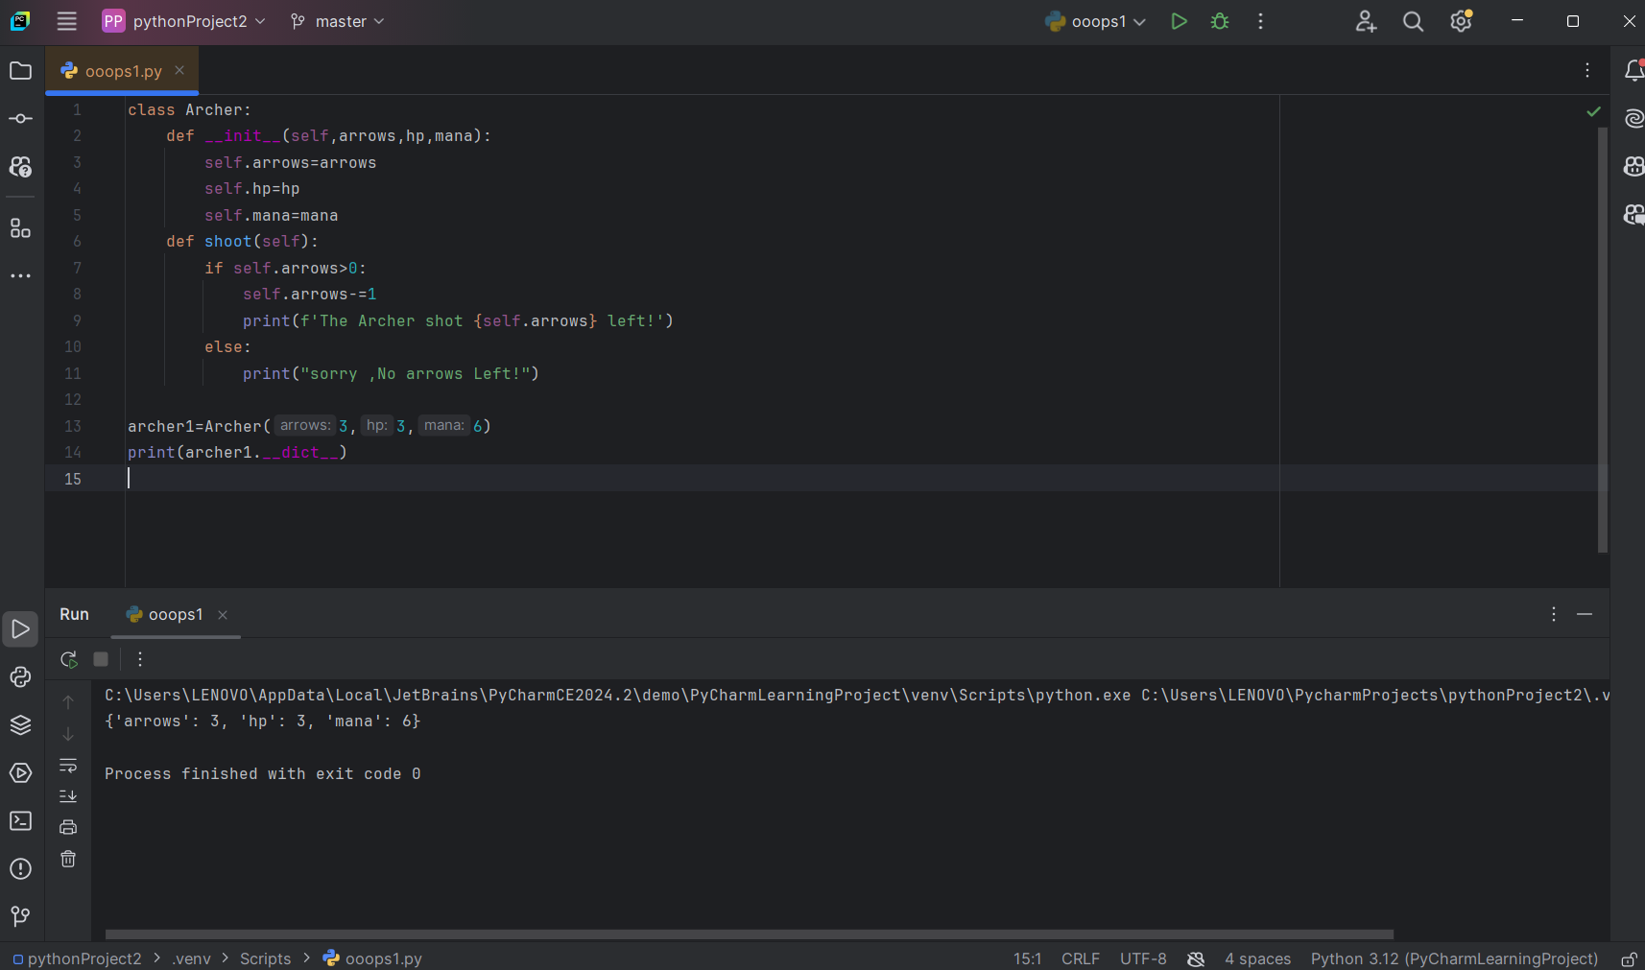

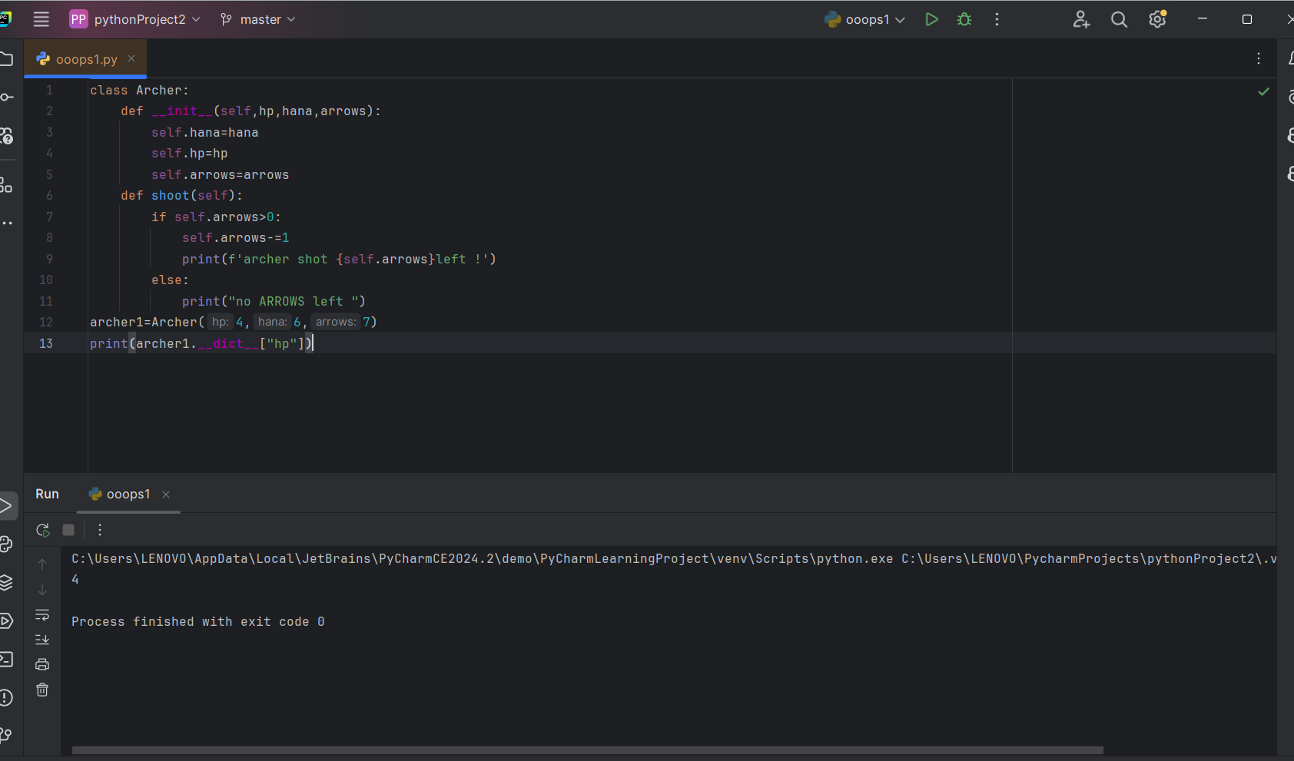

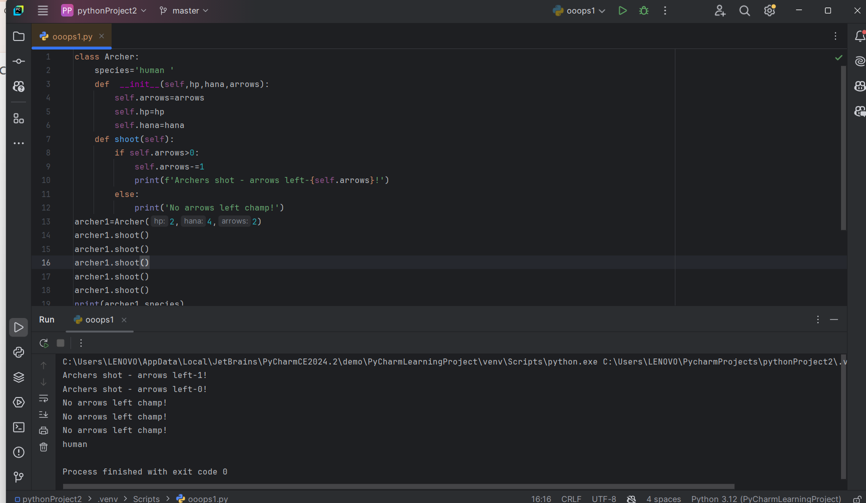

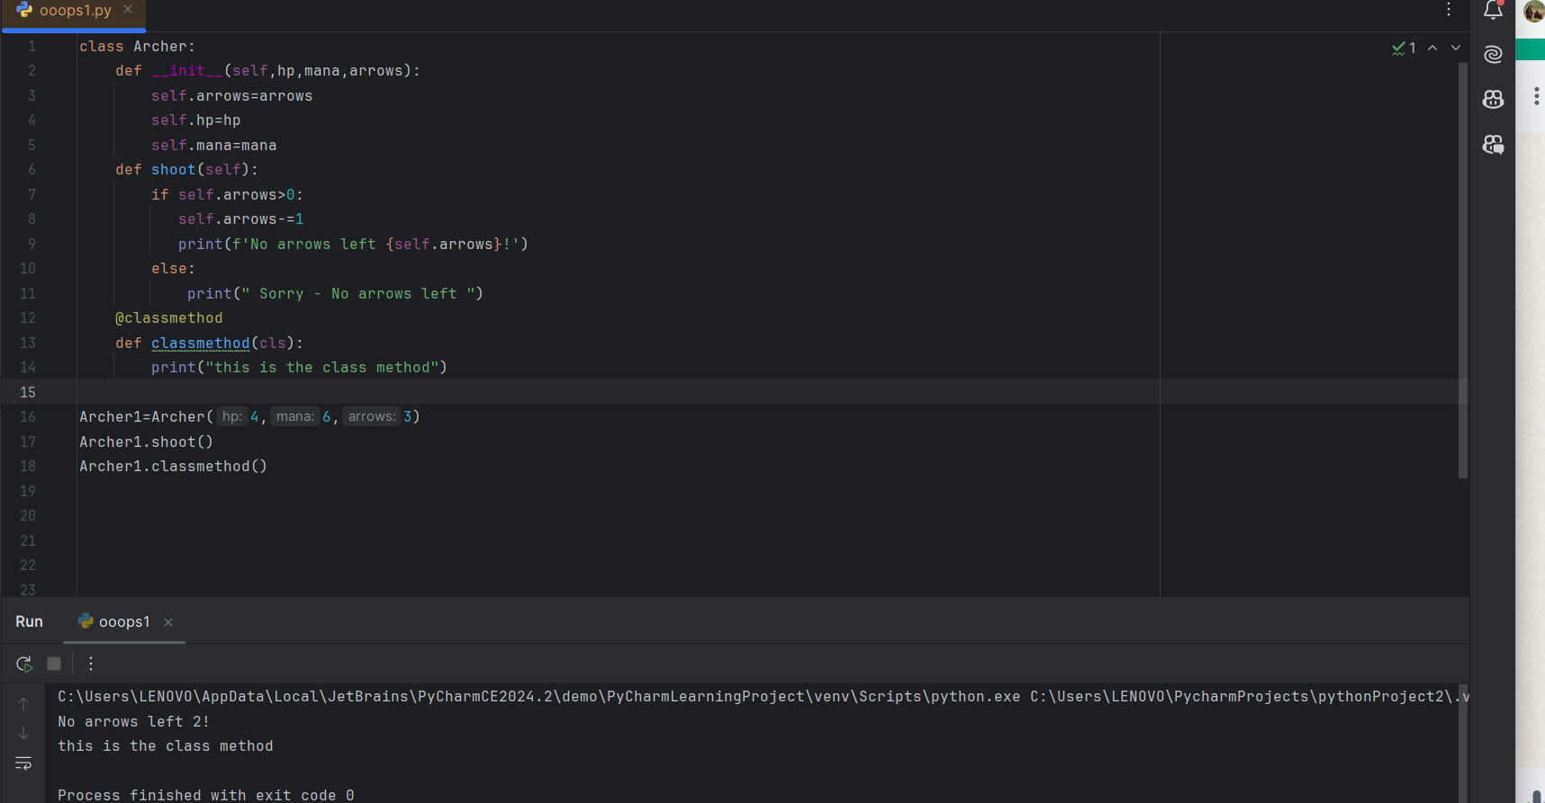

Class method :

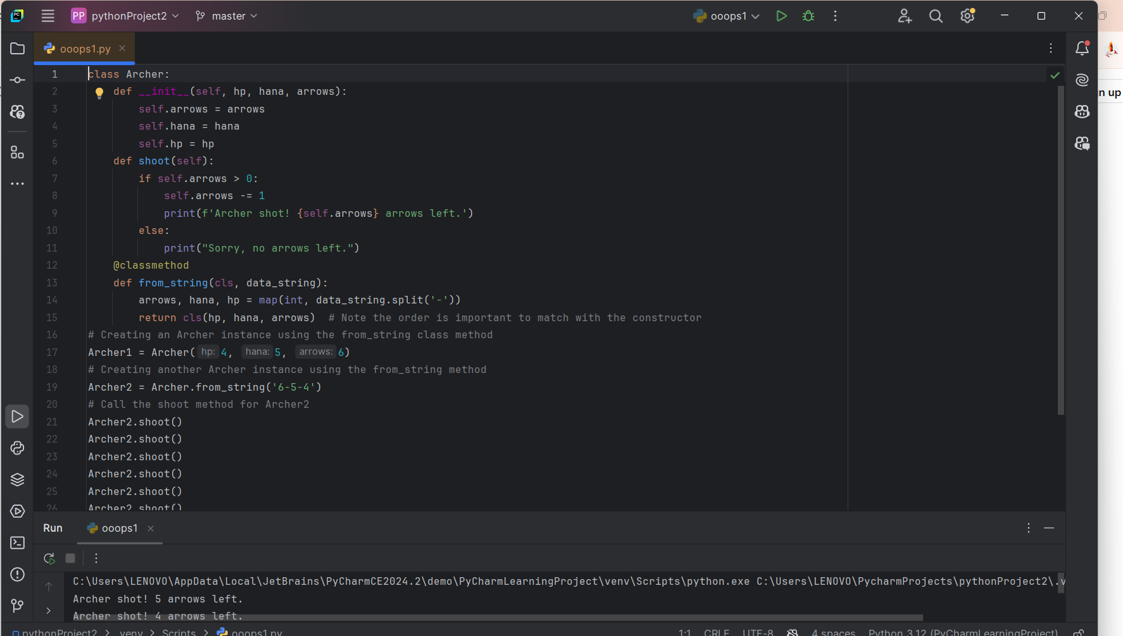

@staticmethod

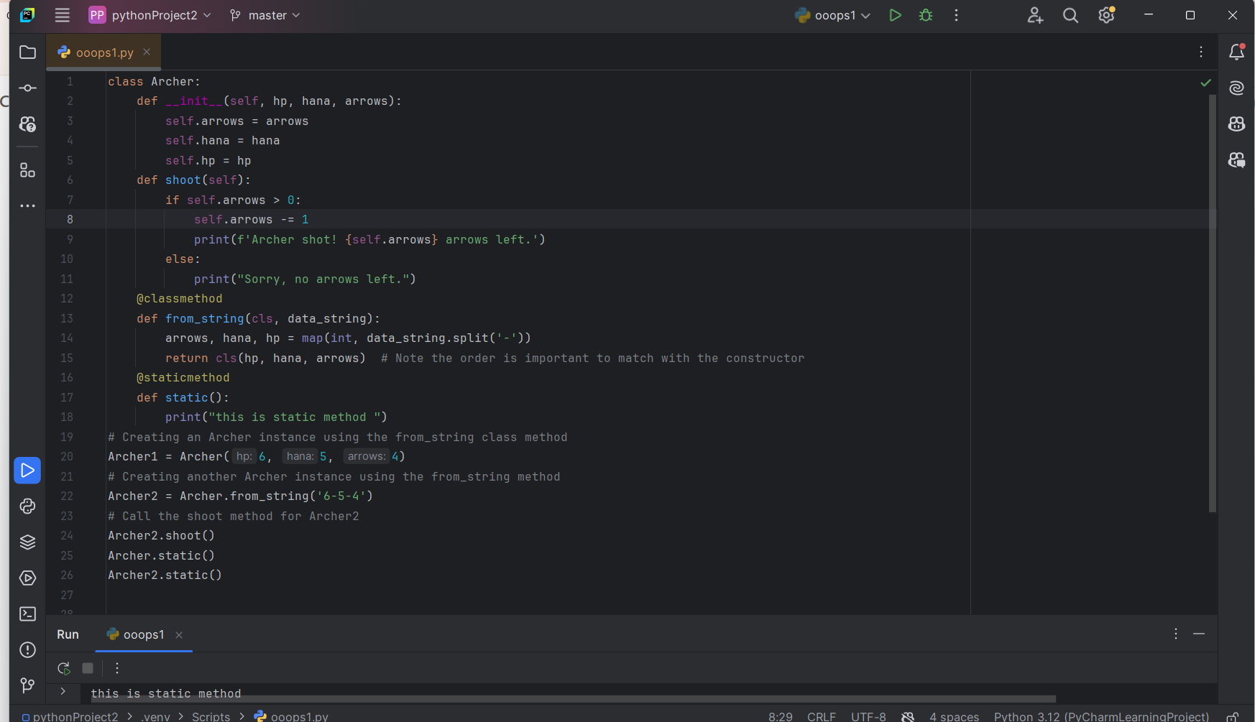

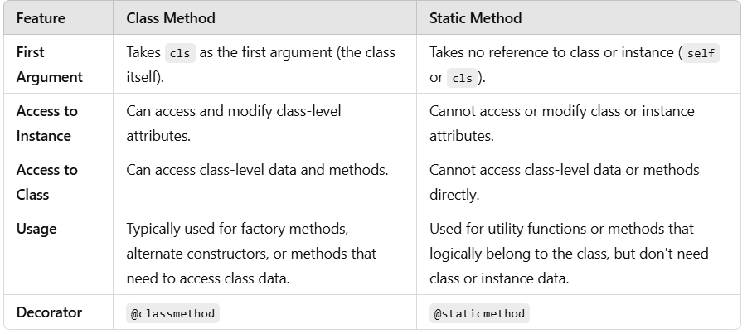

26-11-2024 -11:00am

**Magic methods**/**dunder method**:

In Python, **dunder methods** (short for "double underscore methods") are special methods that have double underscores (__) at the beginning and end of their names. These methods are also known as **magic methods** or **special methods**. They allow you to define how objects of your classes behave when used with built-in Python functions, operators, or certain syntax.

**Examples of Common Dunder Methods:**

1. **__init__(self, ...)**:
   * Called when a new instance of a class is created.
   * It is the **constructor** for the class.

class MyClass:

def __init__(self, name):

self.name = name

obj = MyClass("Alice") # Calls __init__ to initialize the object

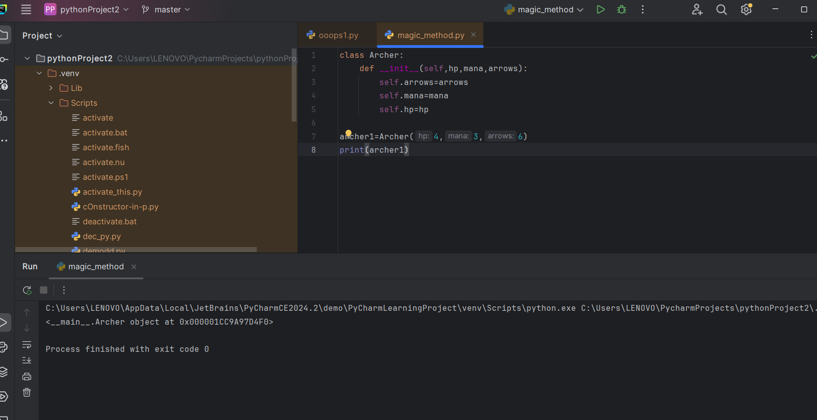

1. **__str__(self)**:

he __str__(self) method is **built-in** in Python. It is a special (dunder) method that is used to define the **string representation** of an object. When you call print() or str() on an object, Python internally calls the __str__() method to convert the object into a human-readable string.

* + Called by the str() function and print() to return a string representation of the object.

class MyClass:

def __init__(self, name):

self.name = name

def __str__(self):

return f"MyClass with name {self.name}"

obj = MyClass("Alice")

print(obj) # Output: MyClass with name Alice

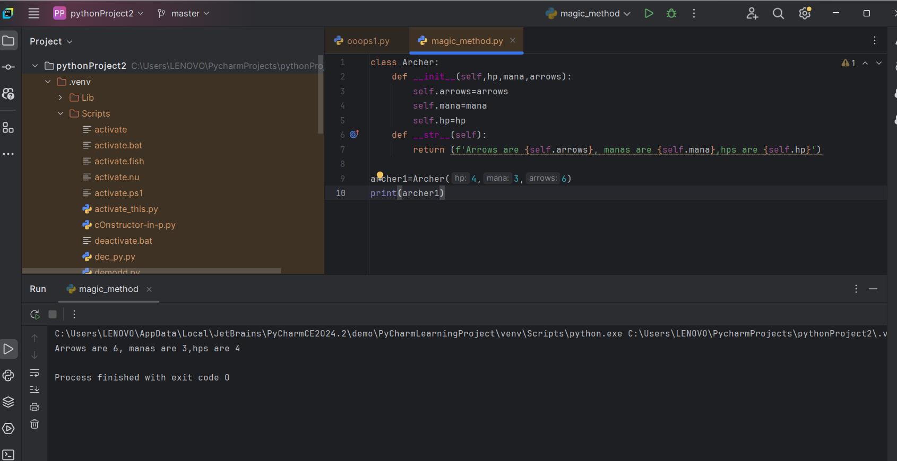

1. **__repr__(self)**:

**How __repr__() Differs from __str__():**

* **__str__()** is intended for creating a **user-friendly string representation** of an object, which is typically shown to the end user (e.g., when you print an object).
* **__repr__()** is intended to provide a more **formal and detailed string representation** that is helpful for debugging and development. It’s often used by the interactive interpreter and the repr() function.

If you define both __repr__() and __str__() methods in a class, Python will prioritize __str__() when you use print() or str(), but it will use __repr__() when you use repr() or in some debugging contexts (like in the interactive shell).

* + Called by the repr() function and is used for debugging and development.
  + It should return a string that, when passed to eval(), would recreate the object.

class MyClass:

def __init__(self, name):

self.name = name

def __repr__(self):

return f"MyClass({repr(self.name)})"

obj = MyClass("Alice")

print(repr(obj)) # Output: MyClass('Alice')

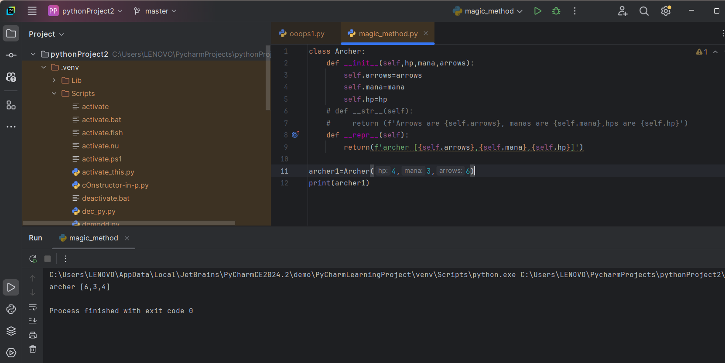

1. **__add__(self, other)**:
   * Defines the behavior of the + operator for objects.

class MyClass:

def __init__(self, value):

self.value = value

def __add__(self, other):

return MyClass(self.value + other.value)

obj1 = MyClass(5)

obj2 = MyClass(10)

obj3 = obj1 + obj2 # Calls __add__ method

print(obj3.value) # Output: 15

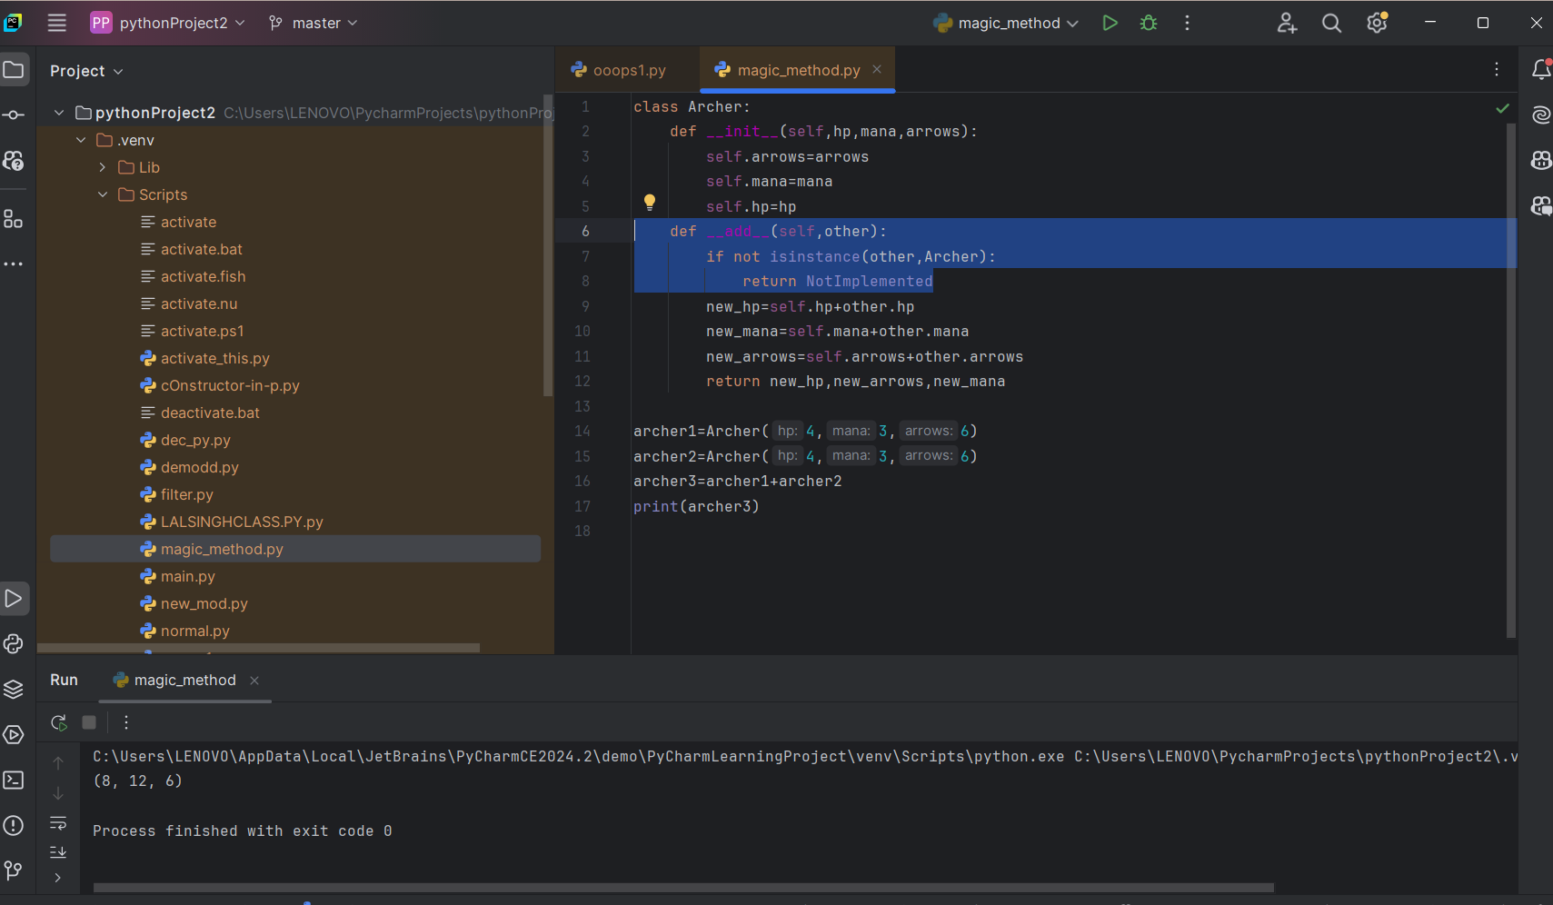

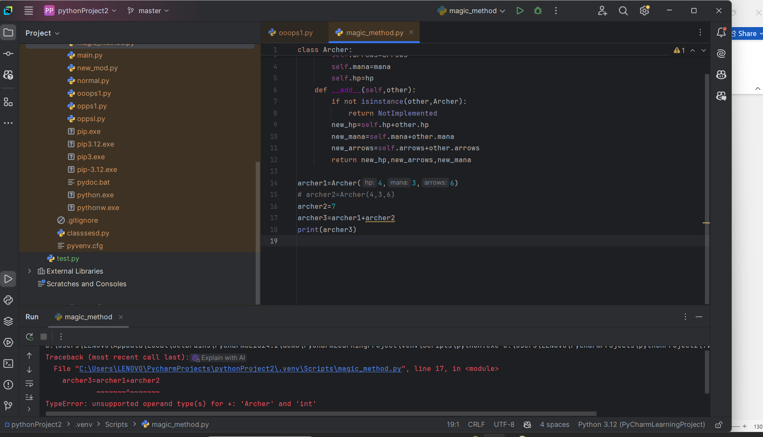

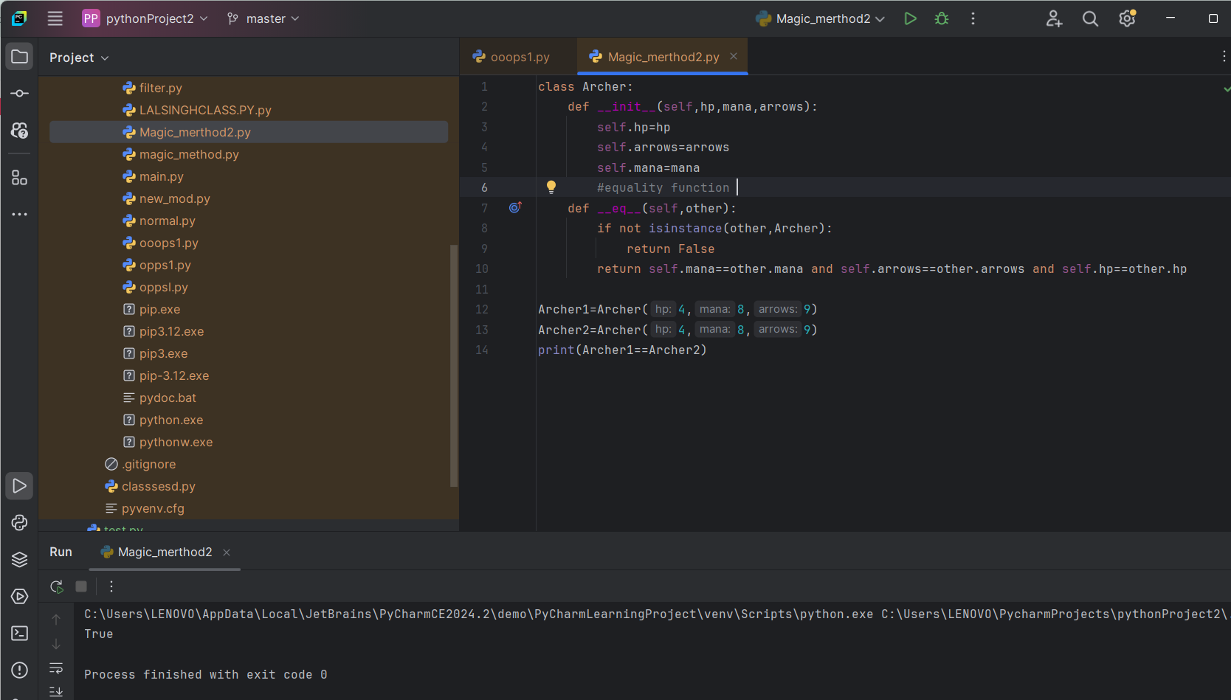

1. **__len__(self)**:
   * Called by the len() function to get the length of the object.

class MyClass:

def __init__(self, items):

self.items = items

def __len__(self):

return len(self.items)

obj = MyClass([1, 2, 3, 4])

print(len(obj)) # Output: 4

1. **__eq__(self, other)**:
   * Defines the behavior of the equality operator (==).

class MyClass:

def __init__(self, value):

self.value = value

def __eq__(self, other):

return self.value == other.value

obj1 = MyClass(10)

obj2 = MyClass(10)

print(obj1 == obj2) # Output: True

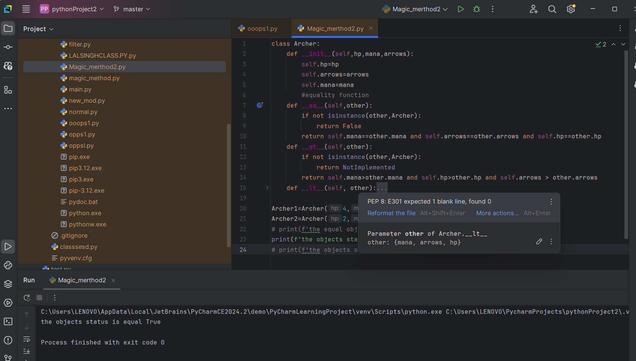

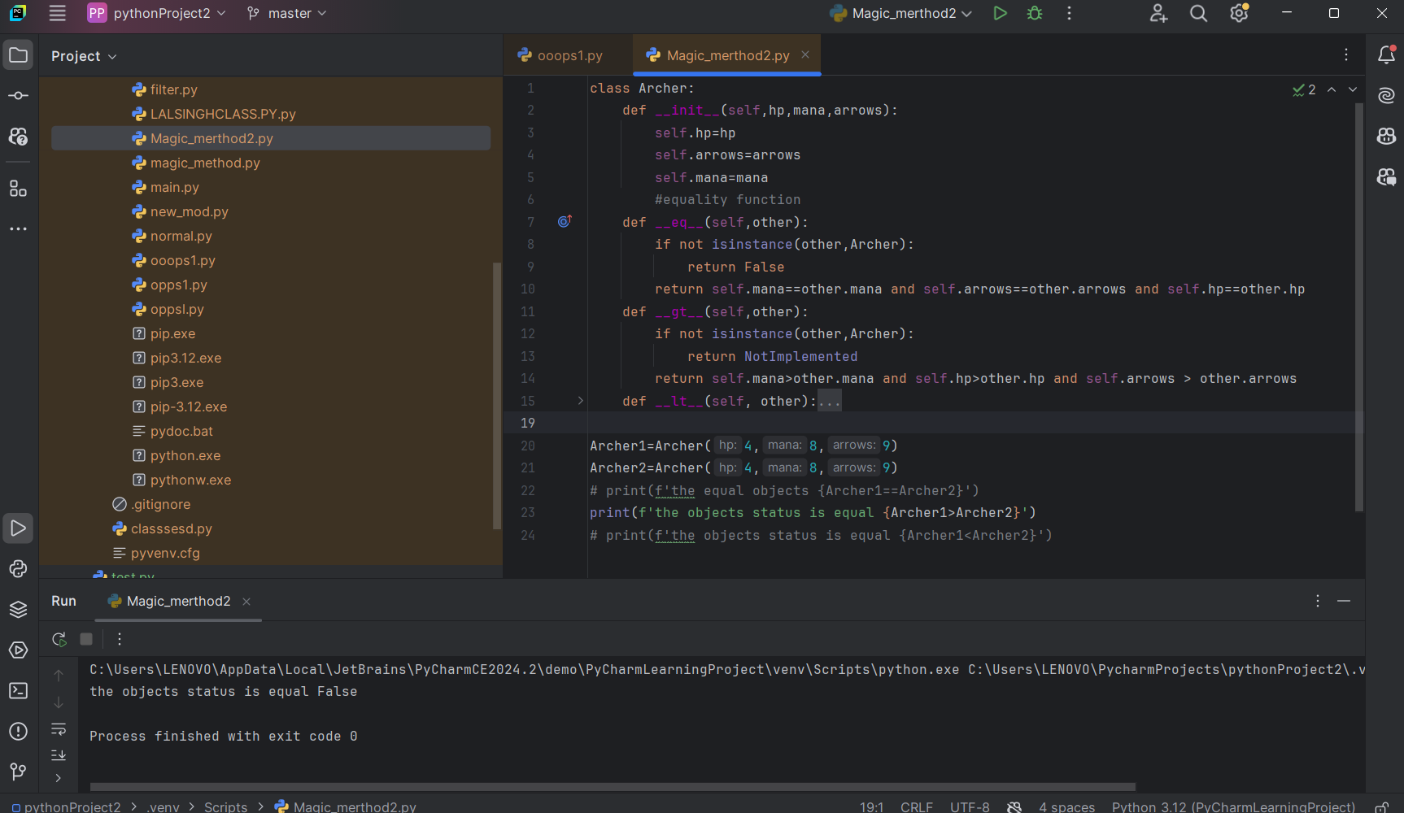

1. **__getitem__(self, key)**:
   * Allows an object to support indexing and slicing, as with lists or dictionaries.

class MyClass:

def __init__(self, items):

self.items = items

def __getitem__(self, key):

return self.items[key]

obj = MyClass([1, 2, 3])

print(obj[1]) # Output: 2

1. **__setitem__(self, key, value)**:
   * Allows assignment to indexed elements, like modifying list elements.

class MyClass:

def __init__(self, items):

self.items = items

def __setitem__(self, key, value):

self.items[key] = value

obj = MyClass([1, 2, 3])

obj[1] = 5

print(obj.items) # Output: [1, 5, 3]

1. **__del__(self)**:
   * Called when an object is about to be destroyed, i.e., when it is garbage collected.

class MyClass:

def __init__(self, name):

self.name = name

def __del__(self):

print(f"{self.name} is being destroyed")

obj = MyClass("Bob")

del obj # Output: Bob is being destroyed

1. **__call__(self, ...)**:
   * Allows an object to be called like a function.

class MyClass:

def __init__(self, name):

self.name = name

def __call__(self):

return f"Hello, {self.name}!"

obj = MyClass("Alice")

print(obj()) # Output: Hello, Alice!

**Why Use Dunder Methods?**

Dunder methods are used to enable objects to interact with Python's built-in syntax and functions, making the class behave more naturally with the language. They also allow customization of behavior for built-in operators and methods, making objects more flexible and intuitive to use.

**Some Other Useful Dunder Methods:**

* __contains__(self, item) — for the in operator (e.g., item in object).
* __iter__(self) — for making an object iterable (e.g., using for loops).
* __next__(self) — for the iterator protocol.
* __getitem__(self, index) — to access items by index.

In summary, dunder methods provide a way to customize the behavior of objects in Python for operations like arithmetic, comparisons, and representation.

**28-11-2024- 8:30Pm**

**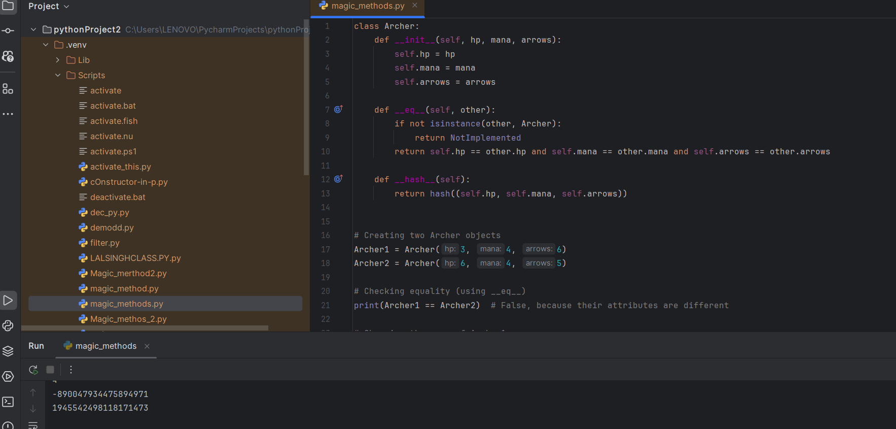  
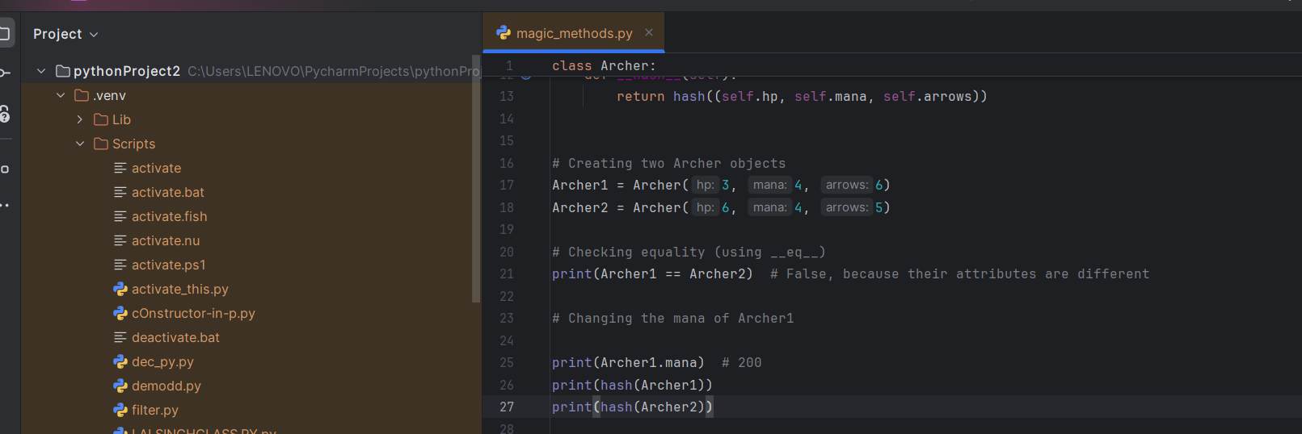**

**29-11-2024 – 9:13pm**

**HASH FUNCTION   
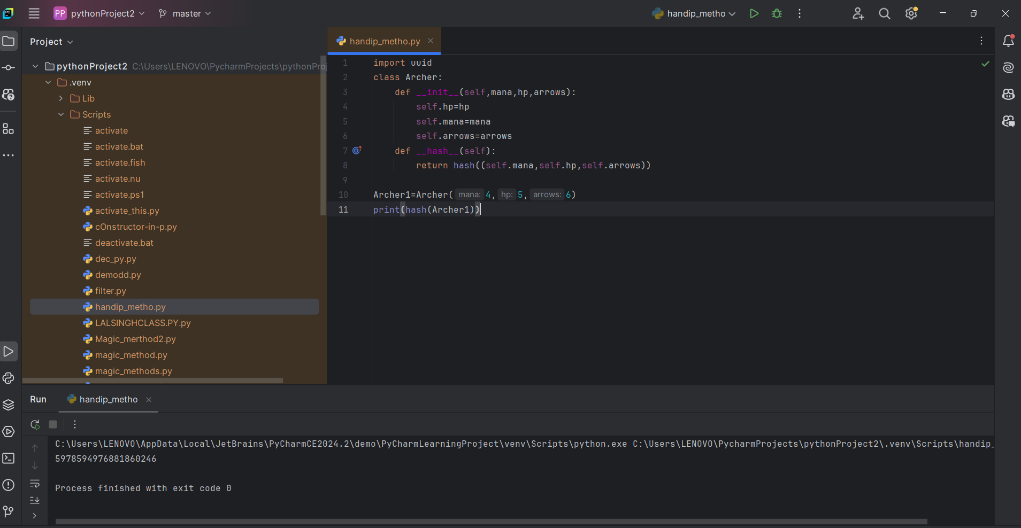**

**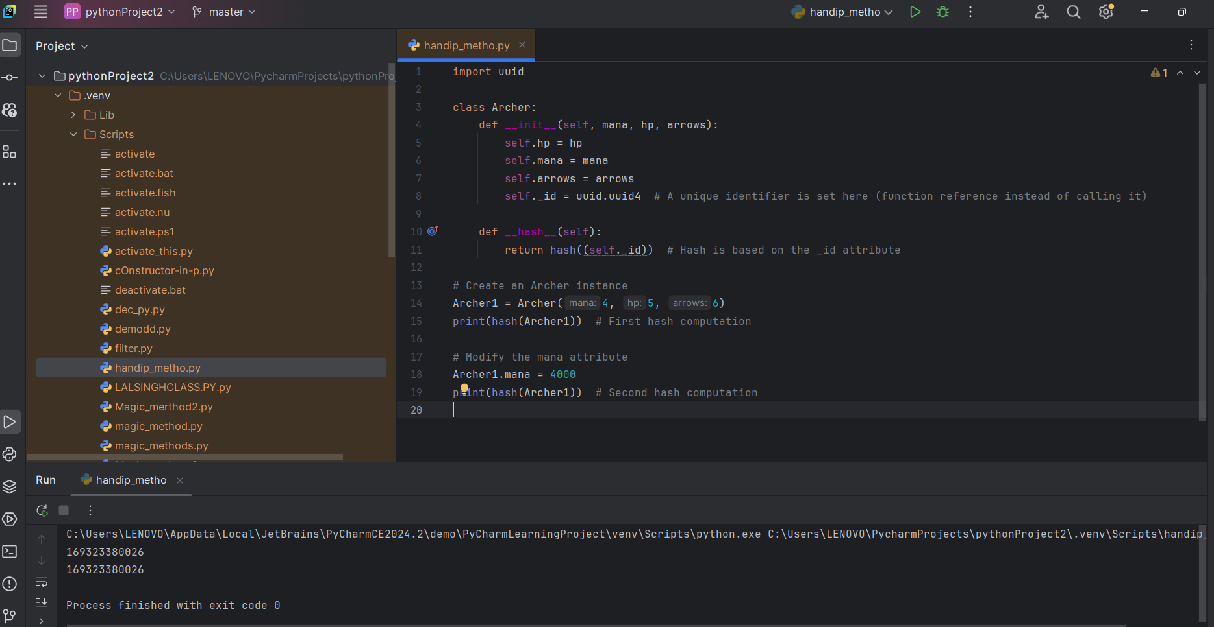  
  
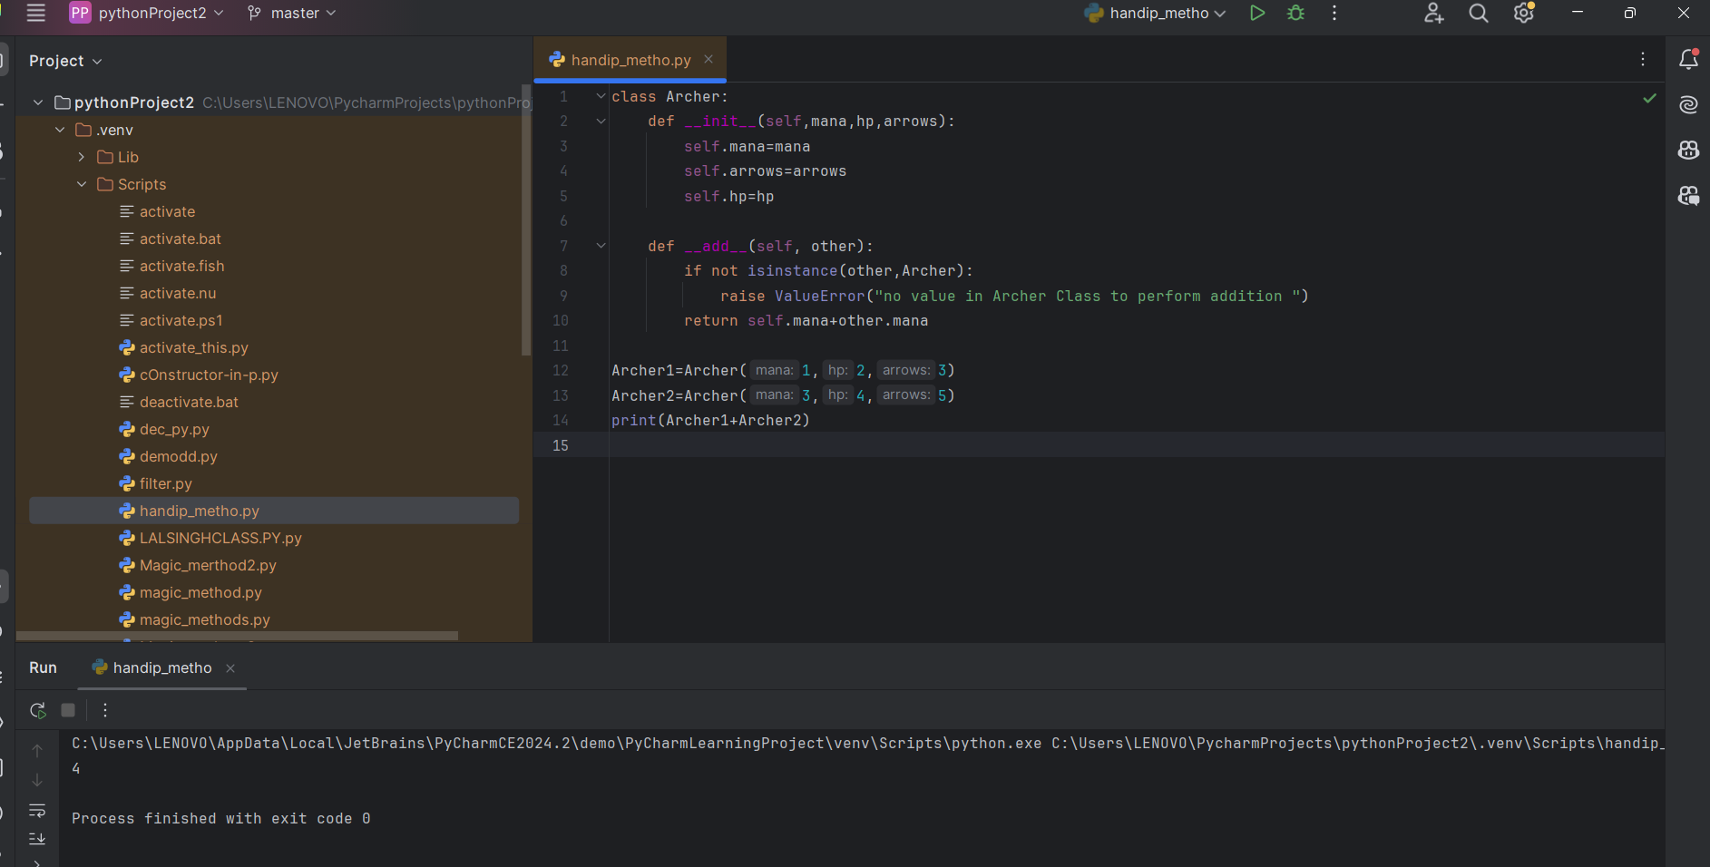**

**INHERITANCE :  
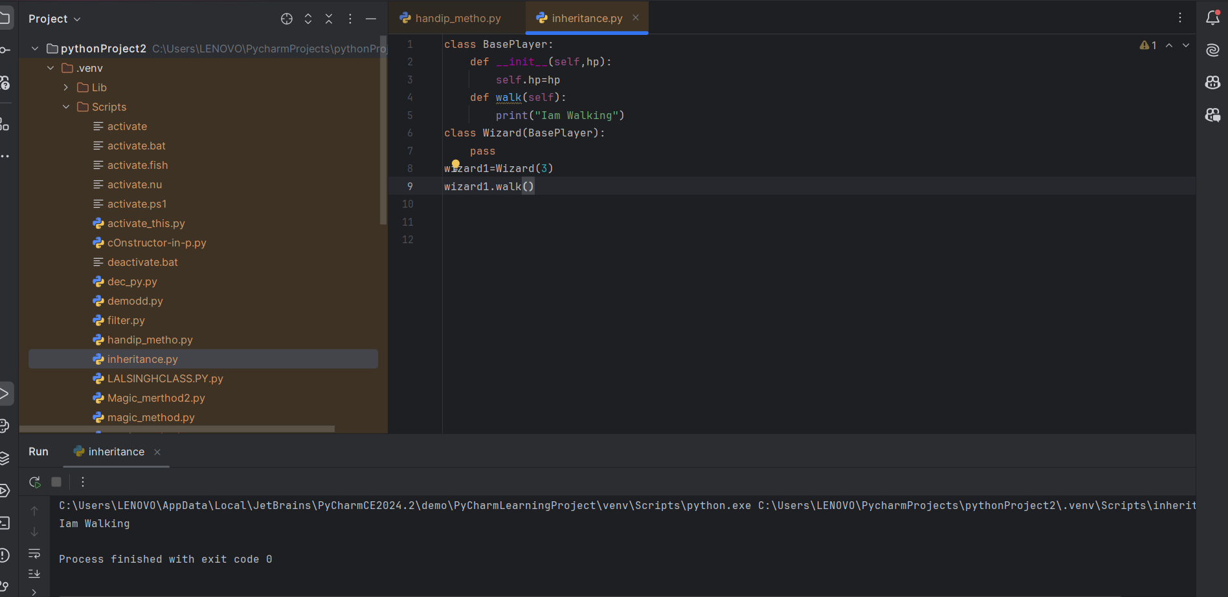**

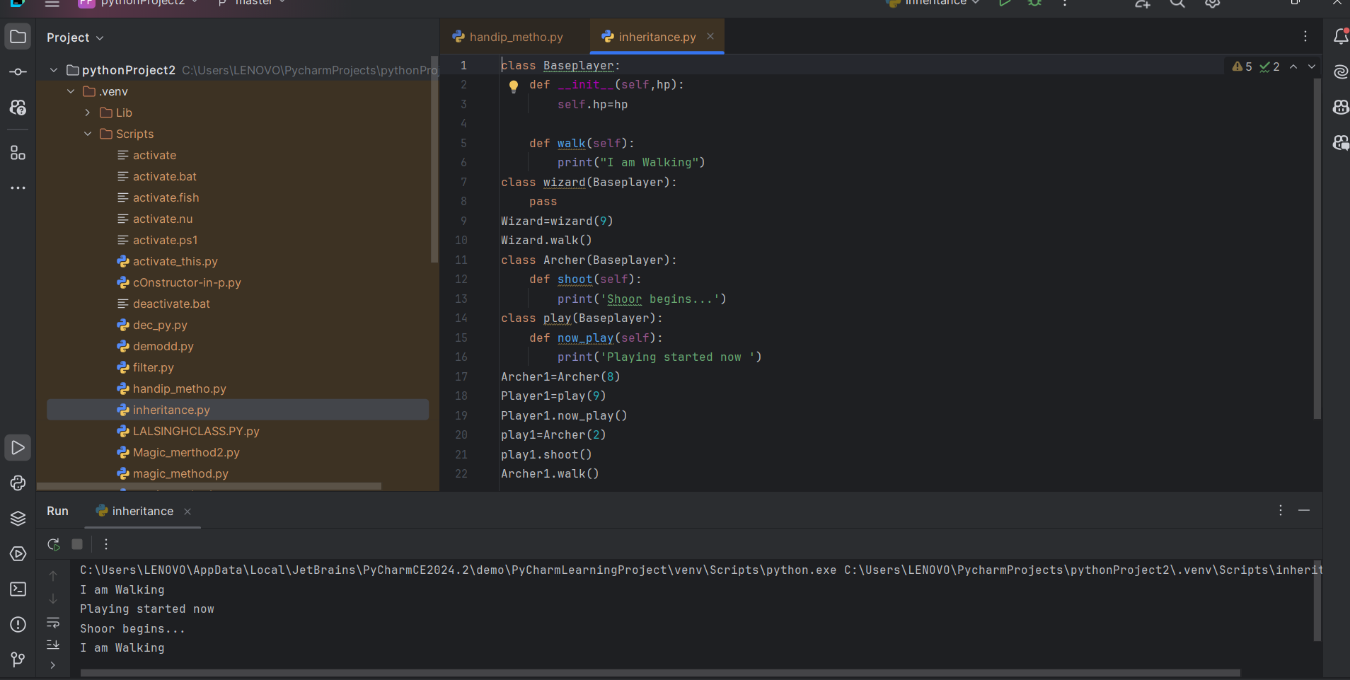

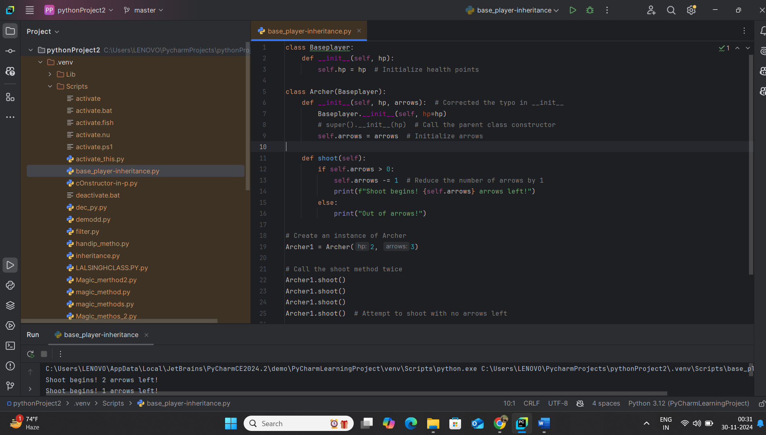

**Data classes and ENUMS :**

**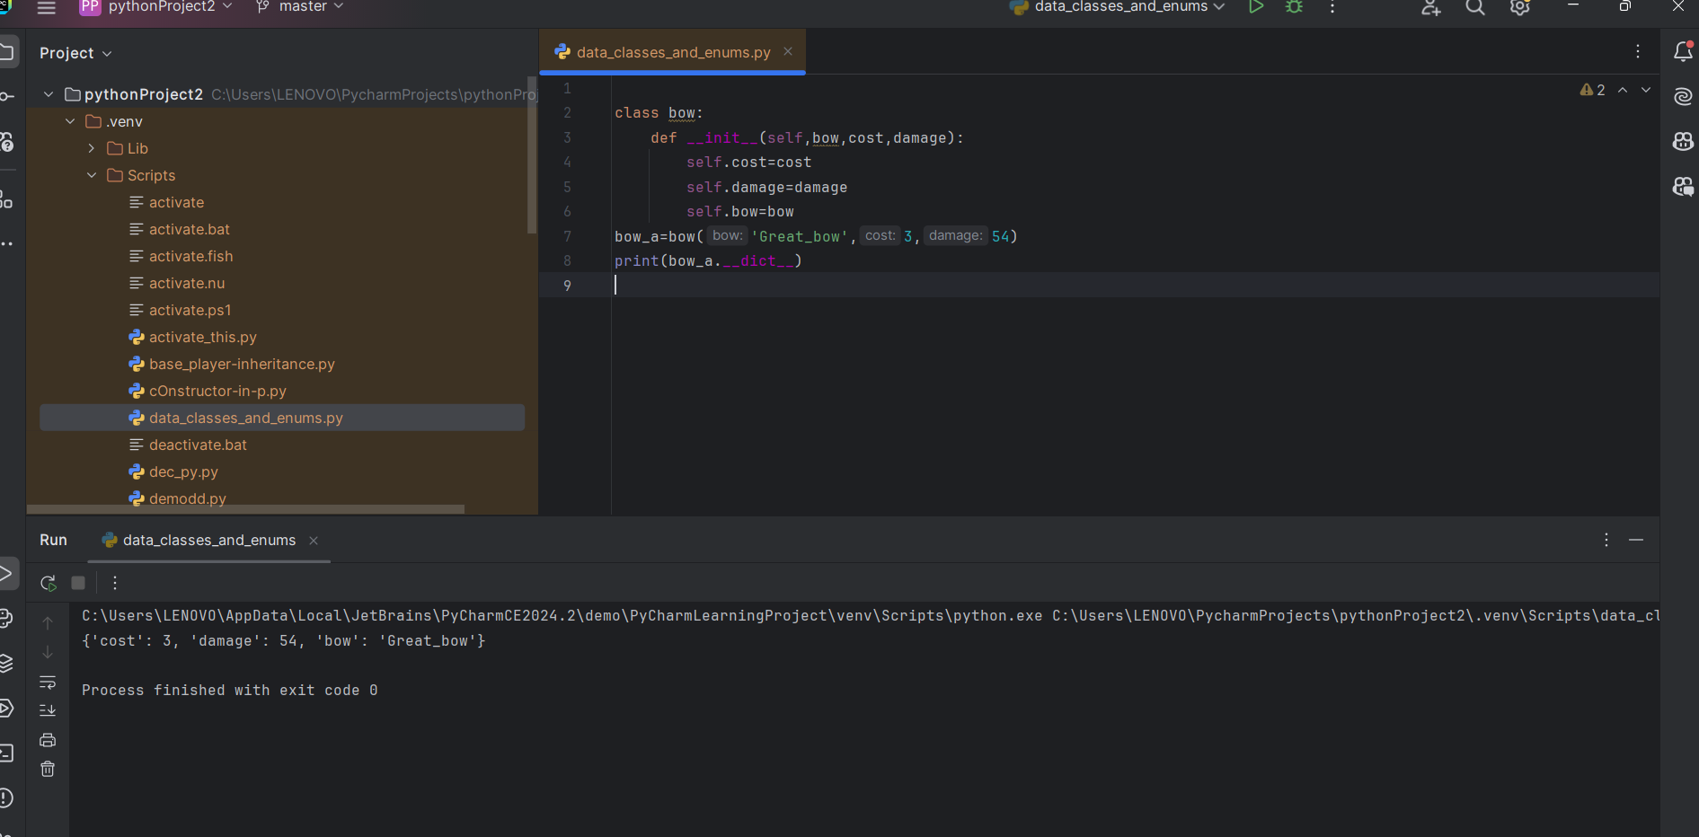  
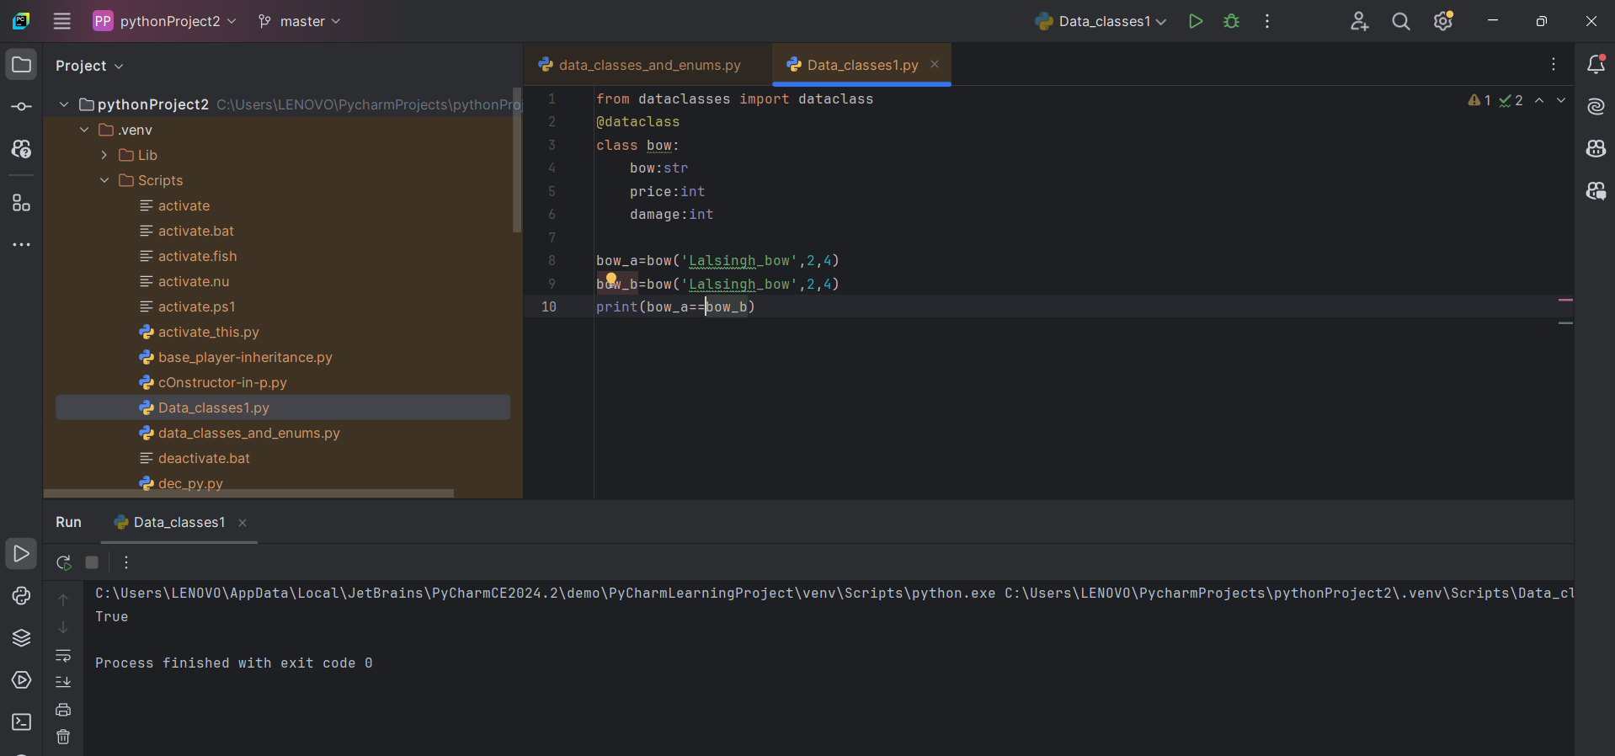**

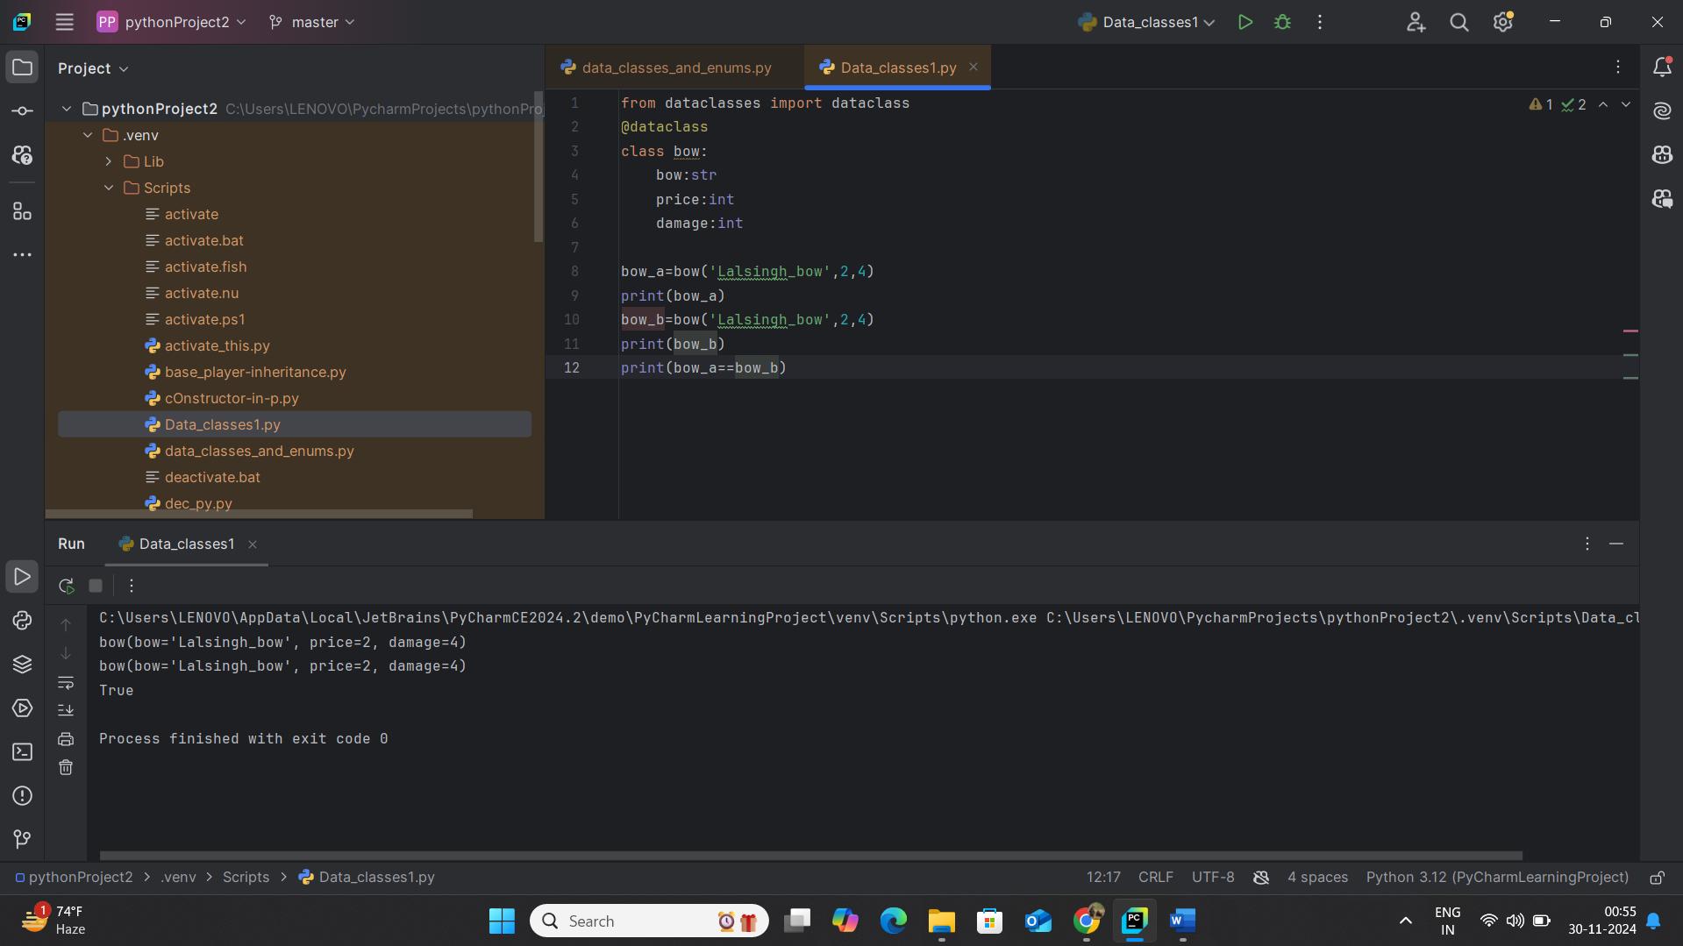

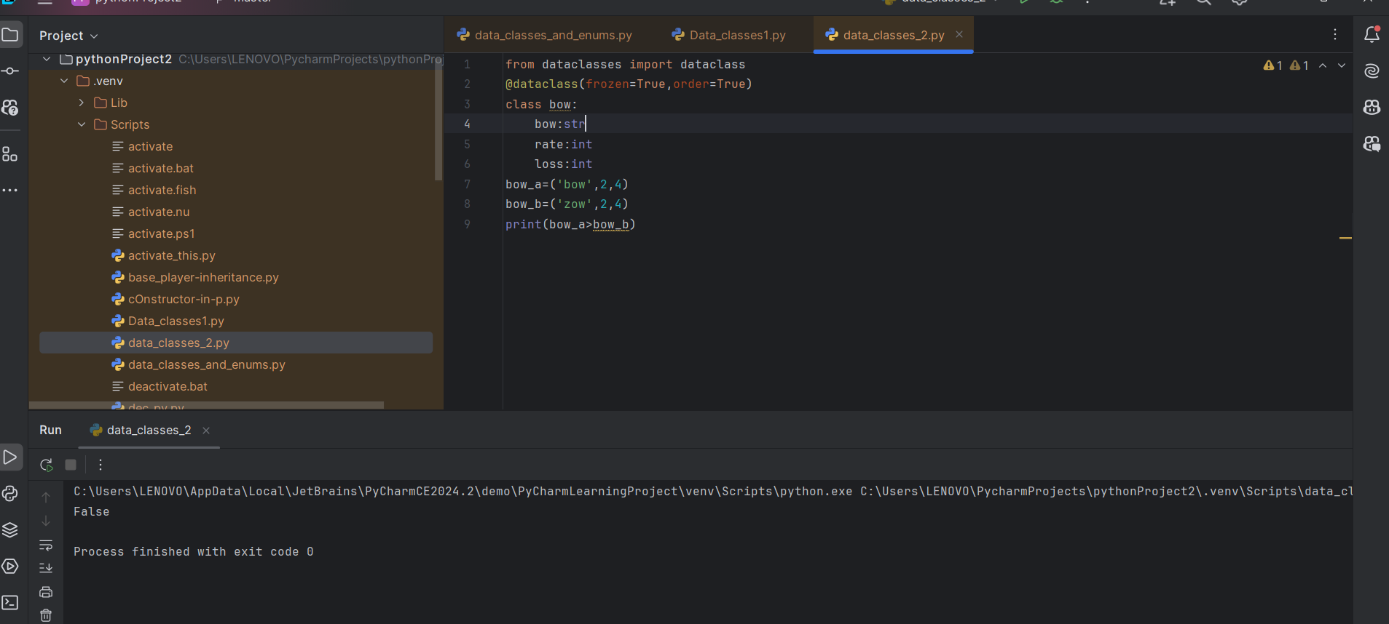

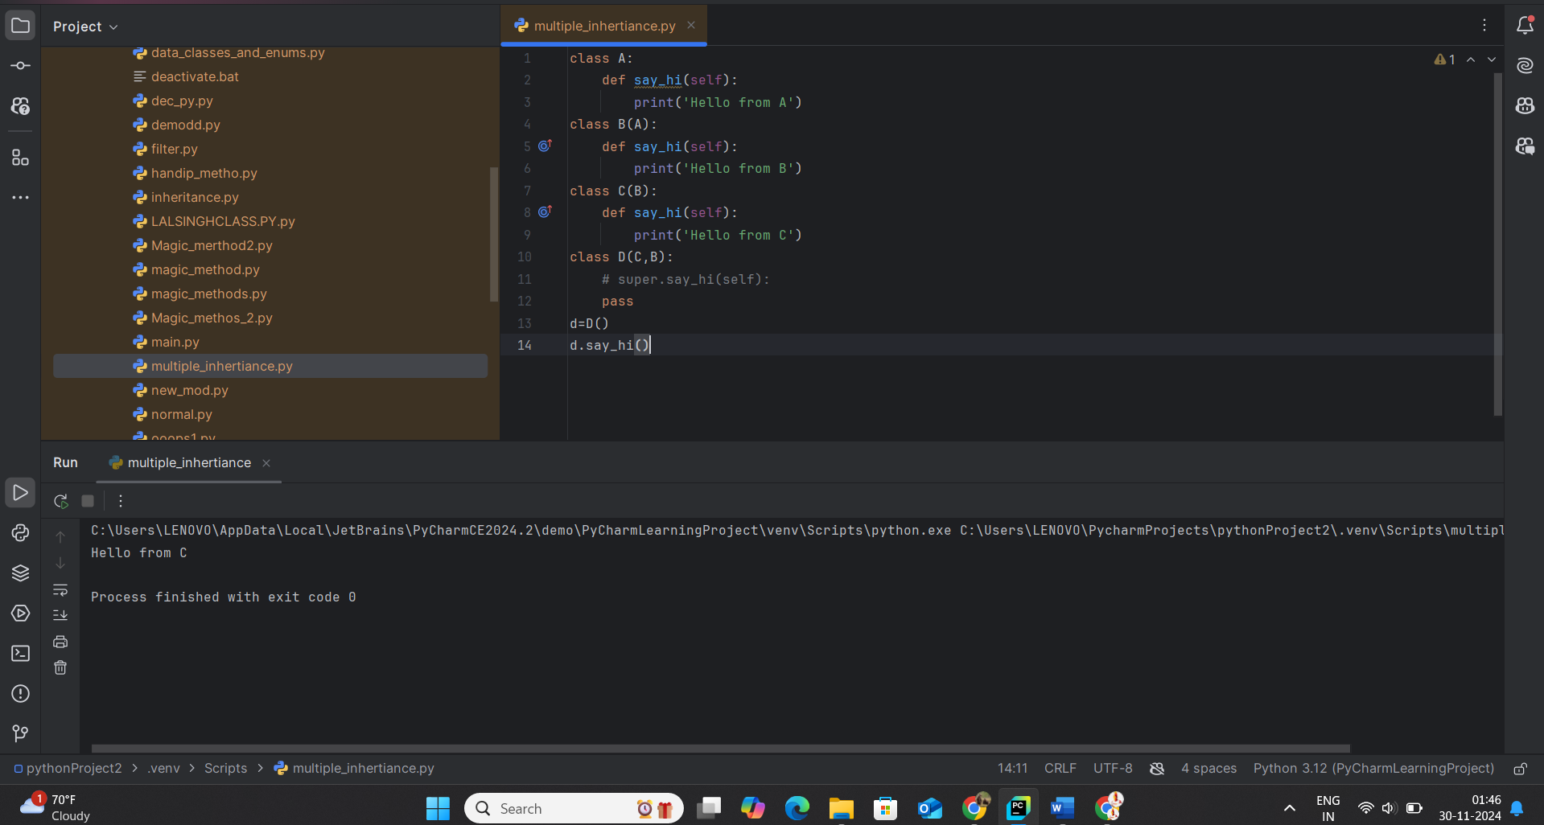30-01-2024 – 8:30pm

**Multiple Inheritance “:**  
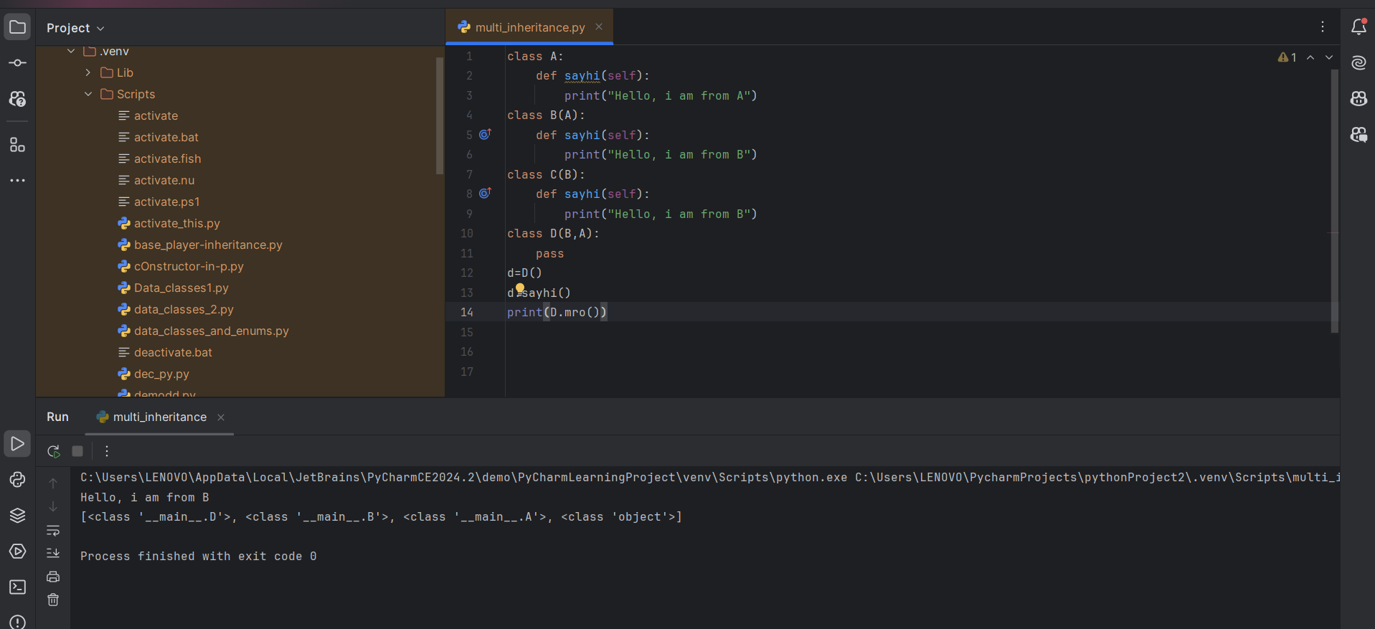

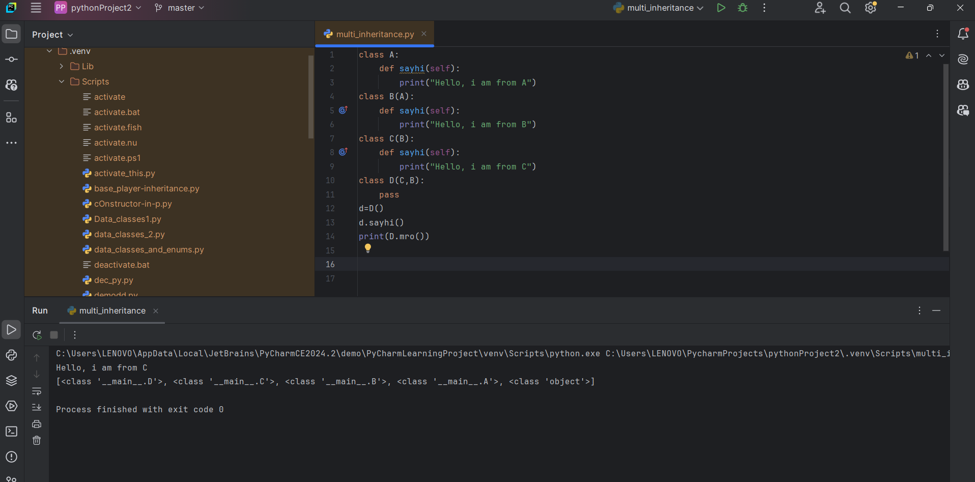

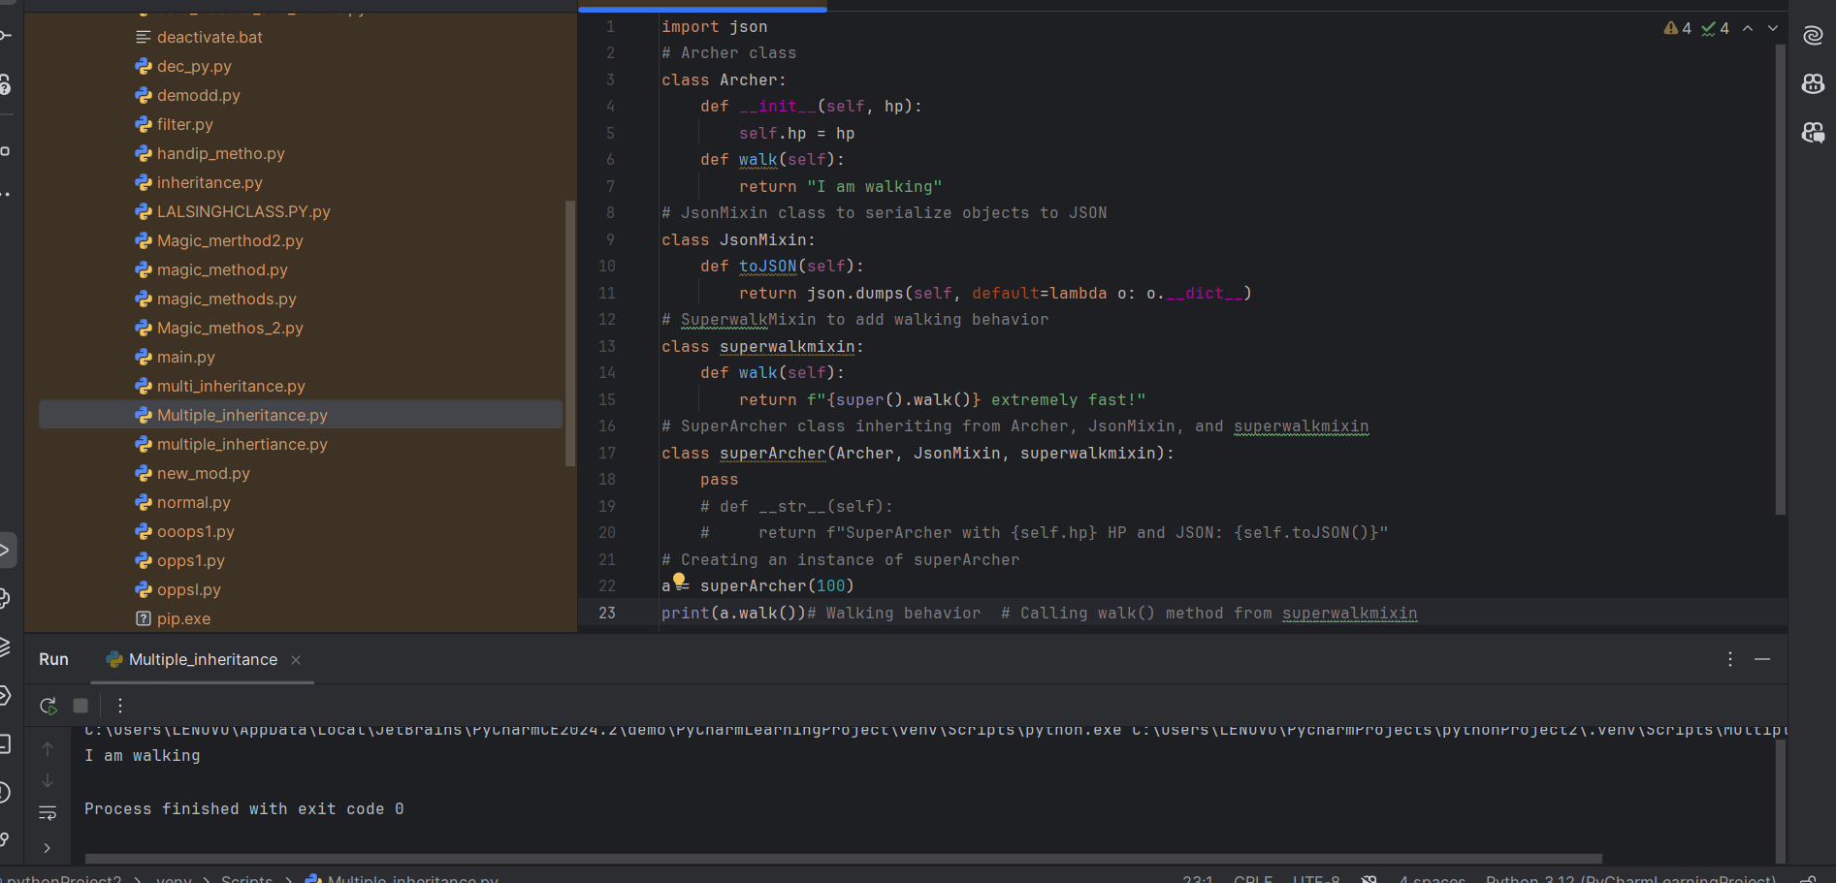

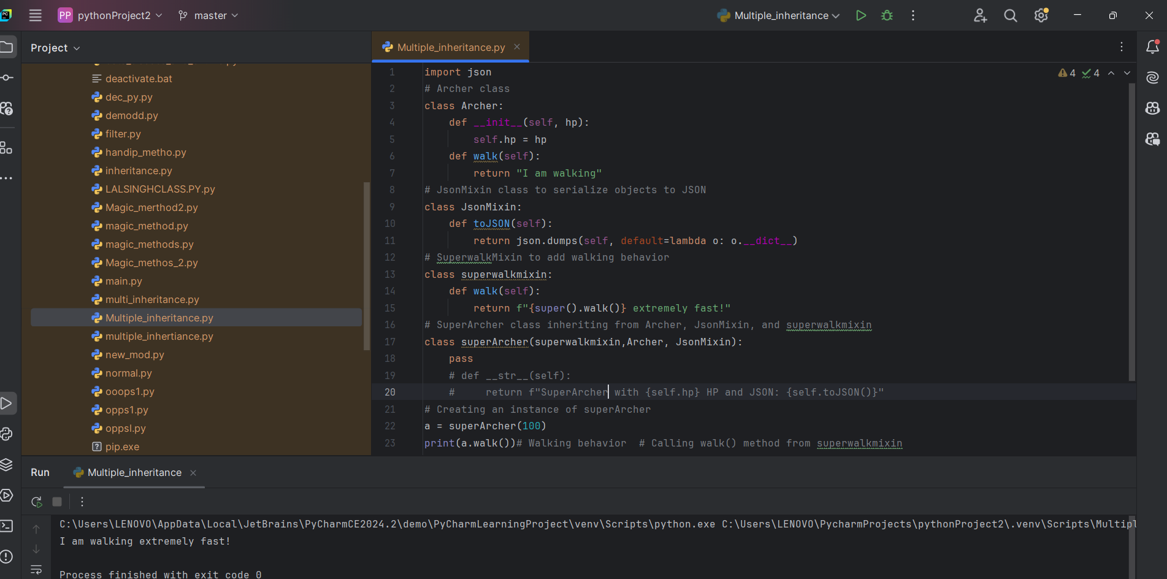**Method resolution order (MRO)**, which determines the order in which classes are looked up when calling a method.

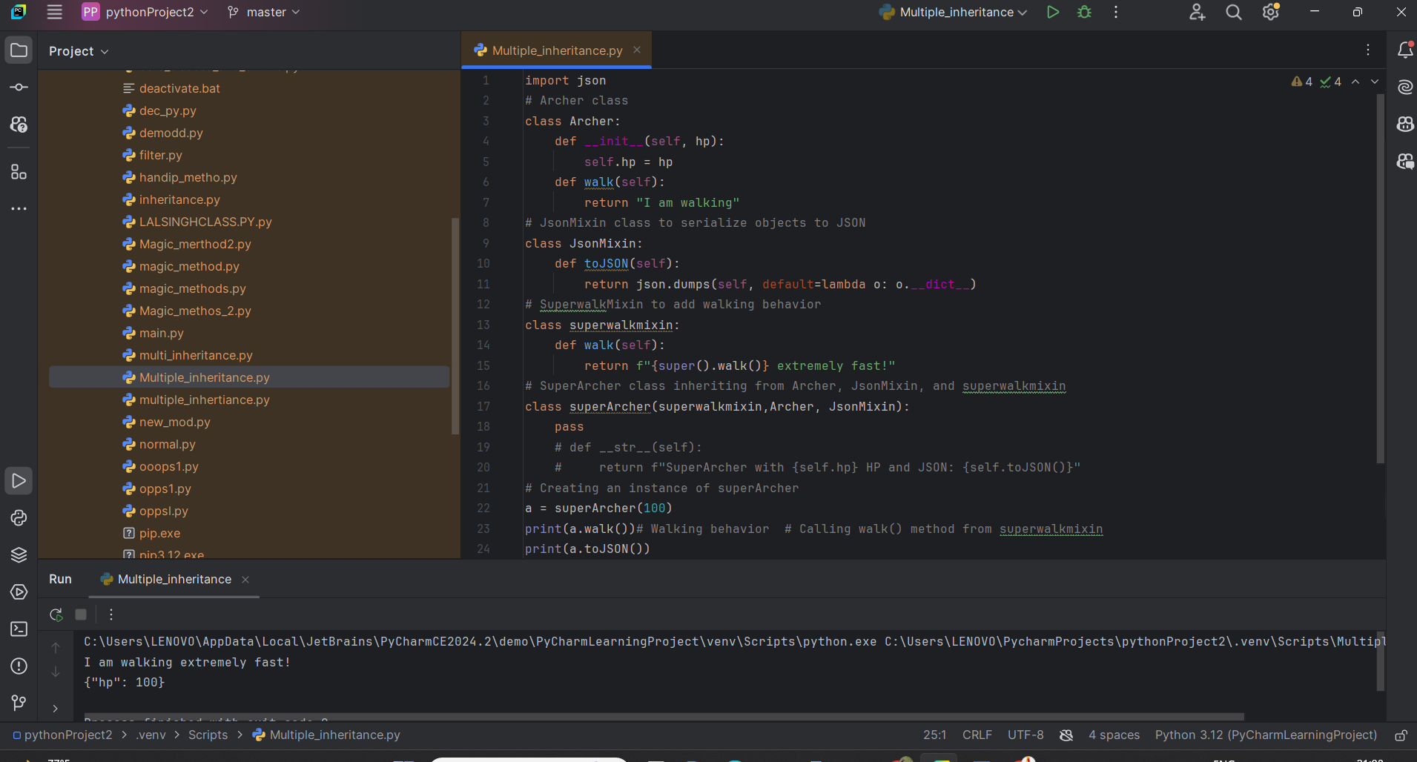

01-12-2024 -7:00am

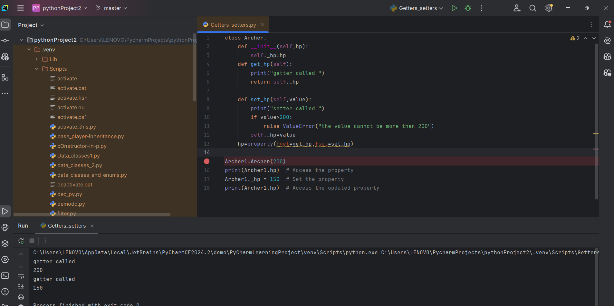

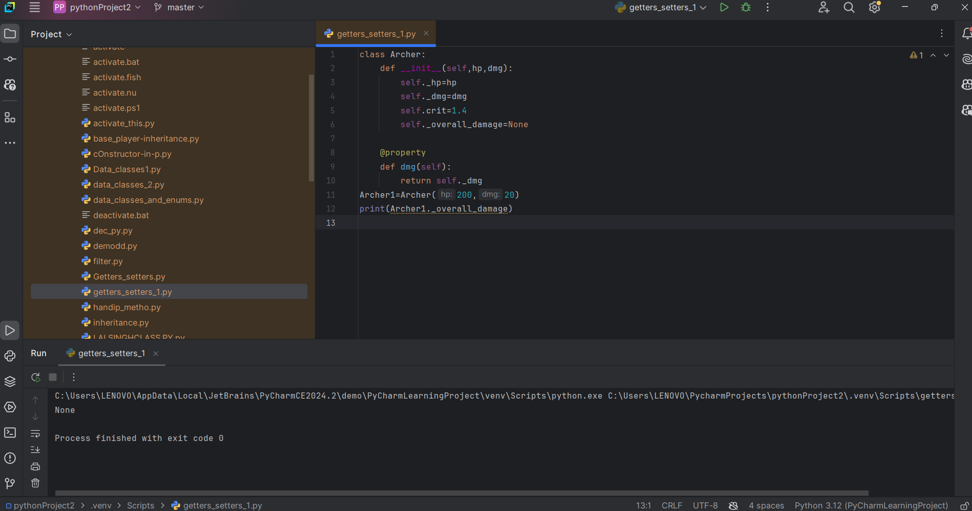

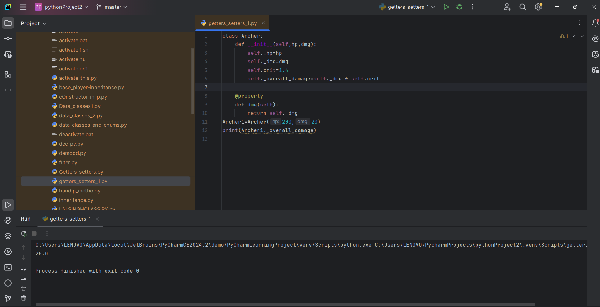

class BankAccount:  
 def __init__(self, owner, balance):  
 self.owner = owner  
 self._balance = balance  
 self._transaction_history = []  
  
 # Getter for balance  
 @property  
 def balance(self):  
 return self._balance  
  
 # Setter for balance (we do not allow direct modification)  
 @balance.setter  
 def balance(self, value):  
 raise ValueError("We cannot set the balance directly.")  
  
 # Deposit method  
 def deposit(self, amount):  
 if amount <= 0:  
 raise ValueError("Deposit amount should be greater than 0")  
 self._balance += amount  
 self._transaction_history.append(f"Deposited INR {amount} Rupees")  
  
 # Withdraw method  
 def withdraw(self, amount):  
 if amount <= 0:  
 raise ValueError("Withdrawal amount should be greater than 0")  
 if amount > self._balance:  
 raise ValueError("Insufficient funds")  
 self._balance -= amount  
 self._transaction_history.append(f"Withdrew INR {amount} Rupees")  
  
 # Property for transaction history  
 @property  
 def transaction_history(self):  
 return self._transaction_history  
  
# Create a BankAccount object  
bank_account = BankAccount("Lalsingh", 1000)  
  
# Check balance (getter)  
print(bank_account.balance) # Output: 1000  
  
# Deposit money  
bank_account.deposit(40)  
print(bank_account.balance) # Output: 1040  
  
# Withdraw money  
bank_account.withdraw(200)  
print(bank_account.balance) # Output: 840  
  
# Try withdrawing more than the balance  
try:  
 bank_account.withdraw(1000)  
except ValueError as e:  
 print(e) # Output: Insufficient funds  
  
# View transaction history  
print(bank_account.transaction_history)